Initiating a FS OP compromise and sending the required form (ES Worker)
Required information to start a compromise
- Agency/County
- PIN for Primary Requester (Abbreviated PR)
- Contact info including address and phone/email (if any)
- Contact info for any Authorized Representative listed

Steps in CWW
Navigate to the Overpayment Claims Compromise – Initiate Request page:
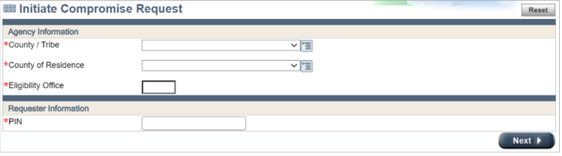
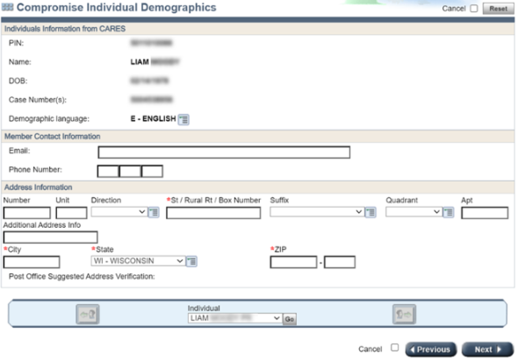
- Enter information in all fields, click next, and complete the address verification page
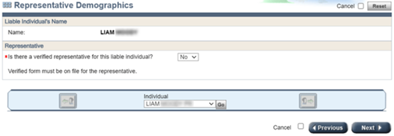
- Select the correct option regarding Authorized Representatives and click Next
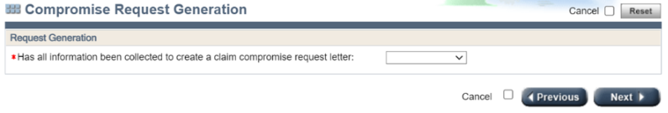
- If you choose YES from the dropdown menu and click Next the form will be generated overnight and mailed.
For instances when a member has found the OCC request form online, completed it, and submitted it to the agency, there is an option to select Manually Received from the dropdown menu on this page so that agencies do not send a duplicate request form.
About the OCC Form
Each OCC form generated includes a cover letter, instructions, and the request form. The form is PIN-based and is expected to be returned in a separate envelope by the liable individual.
On the cover letter an Overpayment Claim Compromise Identifier Number (OCCIN) is assigned. This unique identifier is the number that will be used throughout the tool to navigate for one request and for all the liable individuals tied to that request. A member can never have more than one active OCCIN at a time. The request form instructions explain that the form needs to be filled out or the request will be denied. It also provides submission options.
Several fields within Section 1 and 2 (see below) will be prefilled based on the information that was entered by the IM worker during the steps to evaluate a compromise request. The remaining fields are expected to be completed by the liable individual or their authorized representative.
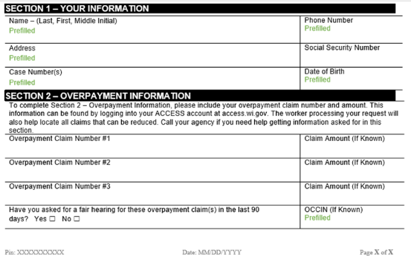
Once an OCC form is completed and received, please notify your lead/supervisor to ensure it is processed timely

