BRITS REFERRAL CREATION GUIDE
Capital Consortium
See BRITS User Manual for more details https://brits.wisconsin.gov/content/help/help.pdf

Program Gatekeeper Office
Matches with County of Residence. CC , FS, and MA will typically start 50**, whereas the W-2 office will start 55**.
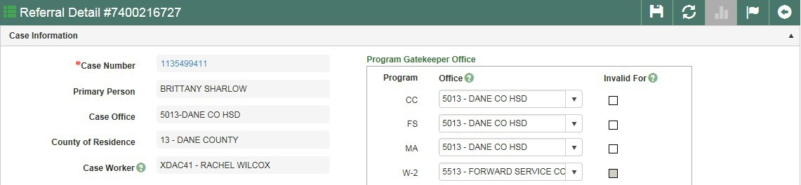

Referral Types
- Fraud Investigation –clients obtaining benefits they are not entitled to through dishonesty. Including but not limited to HH composition (AP in Home, Children Out of Home), forgery, false reports made at applications (APP, SMRF, Renewal). These clients are going beyond failure to follow change reporting requirements.
- Claim Investigation –clients who are overpaid, but not necessarily through acts of fraud. An example is failing to follow change reporting rules. The majority of SWICA fall here. In general, if the overpayment can be established with no further investigation needed and/or only wage reports are needed, it should fall under this category.
- Agency Error – DO NOT USE THIS CODE. It is reserved for agency error over payments. Please use Claim investigation, and allow the OP worker to determine the proper code and change it if needed.
- Front End Verification – Rare. Only to be used if no benefits have been issued and referred in an effort to prevent fraud/overpayments. If benefits have been issued, use one of the other referral types.

Referral Source
Select the most appropriate source. You can find a list of selections in the BRITS user guide (page 266). For example, a referral made based on a SWICA match should be coded with Referral Source “SWICA.” Another example would be to use Referral Source “Child Support” for anything that is referred based on information from the Child Support Agency.

Investigation Reasons
Select the most appropriate reason (you can choose more than one if necessary). You can find a list of selections in the BRITS user guide (page 267). For example, select “Earned Income” for referrals that had benefits overpaid for failure to report wages. Another example would be to use “Household Composition” for AP in Home referrals.

Comments
Please use the BRITS case comment template. The template, instructions, and examples are below:

~ Continued ~

BRITS comment template:

Reason for referral:
Potential OP period:
Programs affected:
Companion case:
What Verification have we Requested/Received: FEV referral sent/which state:
Notes:

Instructions:
Reason for referral: Choose category for referral (Income/HH comp/WI residency/other) Potential OP period: Month and year to month and year of possible overpayment Programs affected: List which programs FS/HC/CC/CTS/etc.
Companion case: List companion case number if there is one
What Verification have we Requested/Received: List any verifications that you have already requested and from what source, or that are in ECF. List data exchange sources to review.
FEV referral sent?/which state: Was an FEV referral sent to check benefits in another state? If so, which state/s? Notes: Please write a narrative of what is going on. Who, what, where, when, and why did you send this referral? (How did you first become aware of this? Was there a discrepancy? Briefly explain your reasoning? Be concise, we will also look at your case comments.)

Example 1: SWICA referral Reason for referral: Income
Potential OP period: Oct 2020-June 2021 Programs affected: FS/HC/CC Companion case: N/A
What Verification have we Requested/Received: Requested EVFE from John’s Auto. FEV referral sent/which state: N/A
Notes: Processed a SWICA discrepancy for second quarter 2021. Discovered employment for Sam Doe with
John’s Auto that was not reported, and there are previous wage matches with this employer going back to fourth quarter 2020. Income reporting limit was $2000 per month, and income appears to be $3000/month from wage match.

Example 2: HH comp Reason for referral: HH comp
Potential OP period: Oct 2019-June 2021 Programs affected: FS/HC
Companion case: 1234567890
What Verification have we Requested/Received: Copy of court order from CS is in ECF, Pended case for HH comp and requested lease/verification.
FEV referral sent/which state: N/A
Notes: Processed a court order from Child Support that states both parents are living in the home since Oct 2019. Jane Doe had not reported Absent Parent in the household previously. AP James Doe has a companion case that is open for FS only and has earned income at Walmart.

Example 3: WI residency Reason for referral: WI residency
Potential OP period: Jan 2021 to June 2021 Programs affected: FS
Companion case: N/A
What Verification have we Requested/Received: Anonymous fraud report that person is living in Illinois. All mail is being returned, and CWW shows all FS usage in Illinois.
FEV referral sent/which state: FEV referral sent to Illinois to check if open for FS there.
Notes: Joe applied for FS in January. He stated he was living in Madison at 555 Regent St at the time of application. We received an anonymous report that Joe lives in Illinois and has always lived there. The case notes indicate all his mail has been returned from his address. CWW shows all FS purchases have been in Illinois. Called customer about WI residency, but unable to reach him.

What Makes a Good Referral? Changes detailed in the new OPS MEMO 21-25

- Eligible Look Back period is now 1 year from date of discovery for all non-fraud related overpayments.

If fraud is suspected please make sure to note in the referral comments as we can potentially recover beyond the 12 month look back period. Fraud related overpayments can go back up to 6 years.
- Food Share defines the date of discovery as “the date the overpayment worker creates the overpayment claim in the system and triggers notice to the member.”

Examples of items that should NOT be referred
- CC only referrals that are co-payment adjustments only
- SWICA matches for 1 Quarter (be sure to update the ongoing benefits)
- Potential FS total OPs under $500
- Potential HC OPs unless there is serious fraud and prosecution may be warranted

Keep in Mind…

Note: The policies described in Ops Memo 21-25 do not override any temporary policies in place during the COVID-19 pandemic, including but not limited to the prohibition on assessing overpayments for months during the federal public health emergency.

For Reduced Reporting FS cases, the following are commonly believed to be overpayments, but are not:
- moved to other state,
- failed to report incarceration
- already over 130% FPL and have increased income
SWICA matches rarely create an overpayment if only one quarter is in question, based on income report rules. Clients will normally have until the 10th of the following month to report income changes. For example, if the client goes over 130% FPL in January, they will have until February 10th to report, to impact March benefits.
When sending any type of referral, update the ongoing CWW case appropriately (i.e. pending for AP in Home, pending for earned income based on SWICA discrepancies).
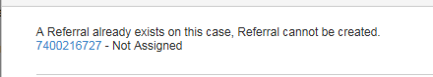
Typically, only one referral can be open/pending per case. If you are unable to create a new referral because one already exists, you will see the following message. In these situations, add comments to the existing referral:

There are times when another referral can be created. This will only work with data exchange referral sources (Interstate UCB Match, SWICA, Prisoner Match, SOLQ, Unemployment Insurance Match, DCF PARIS Reports or DHS PARIS Reports). Create a new referral if you receive the below message:

The following Data Exchange referral(s) with the same Referral Source exist(s). 3000000043 - Not Assigned
DON’T CHECK THE BOX! When processing a SWICA in CWW, please do not check the overpayment referral box with the SWICA discrepancy. Capital does not use this to track overpayments, and you will need to go back into CWW to uncheck the box if you use it mistakenly.

