**How to Issue an Enrollment Fee**

Enter the case that you are working on in CSAW.

On the Left side navigation menu click on

“**REGISTRATION FEES”** Link

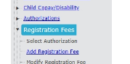

Then click on the **“ADD REGISTRATION FEE PAYMENT”** link

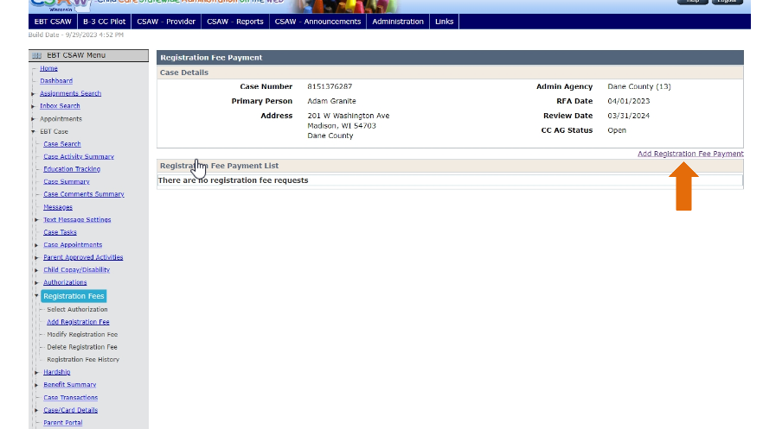

Next click on **“SELECT”** by the child that you looking for to enter in the fee for. If the child has more than one authorization, make sure you select the correct authorization/provider for the child.

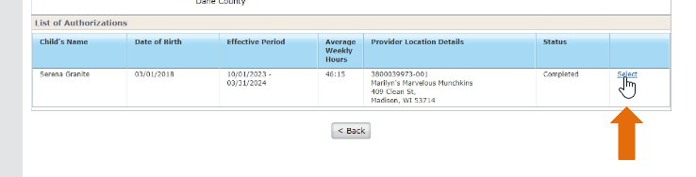

The page will display the provider current fees the provider charges.

If the provider does not have any reported fees then it will say “there are no provider fees”. The request date will auto-populate with today’s date.

Select “**ADD”** to confirm that a Fee amount should be added to the case. The system will automatically use the provider fee up to $125.00. You do not need to click on “other amount” unless the parent reported they are getting a discount on the fee.

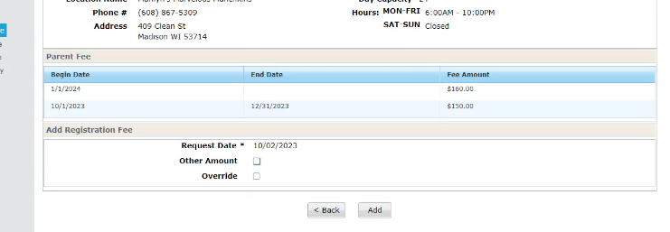

A **Hard Stop Error Banner message** will display if the provider has no reported fees.

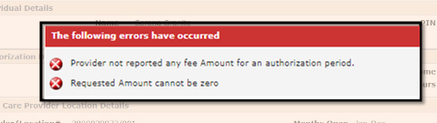

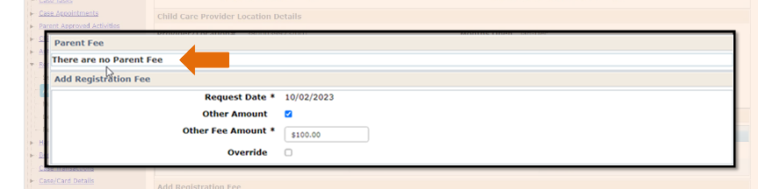

A hard stop error Banner message will also appear if a Registration fee was approved for the same child and provider within the past 30 days.

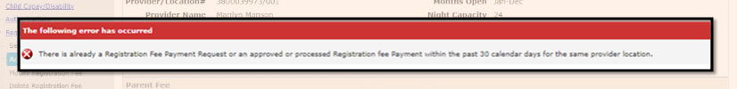

If a **Red Banner Error Message** appears that the Provider has No Reported Fees, then see the desk aid on Enrollment Fee Module Process page 2 for follow up procedure.

After you have selected **ADD,** a Registrations Fee Payment List will show the Fee request and status. If the parent has reached their Fee Limit, the system will automatically deny the request.

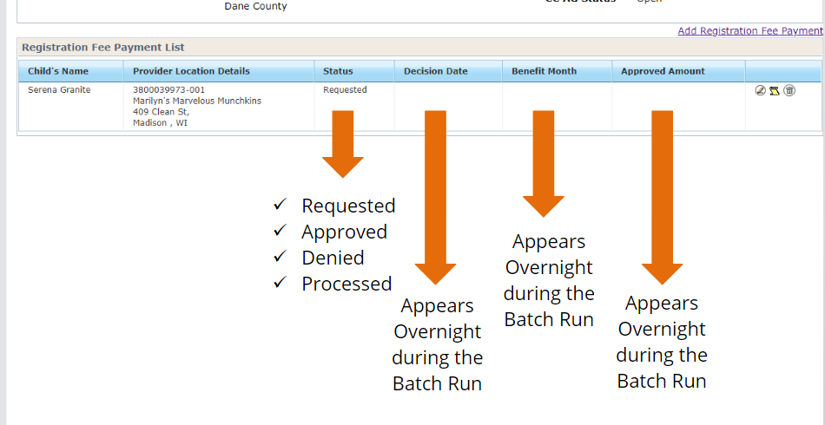

Overnight the status will change to **Processed.**

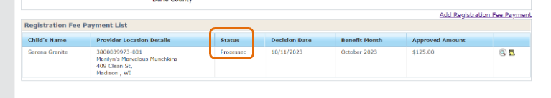

On Case Transactions the enrollment fee will show as a separate line item however the amount will be added to the total current account balance.

