**Hmong Queue Voicemail**

This team (Joan/Jeremiah/CCC Admin) will monitor the Hmong voicemail queue and delete off the old voicemail in order to start a new clean week on a weekly basis. To get the voicemail, this PASSWORD code 32050 is needed.

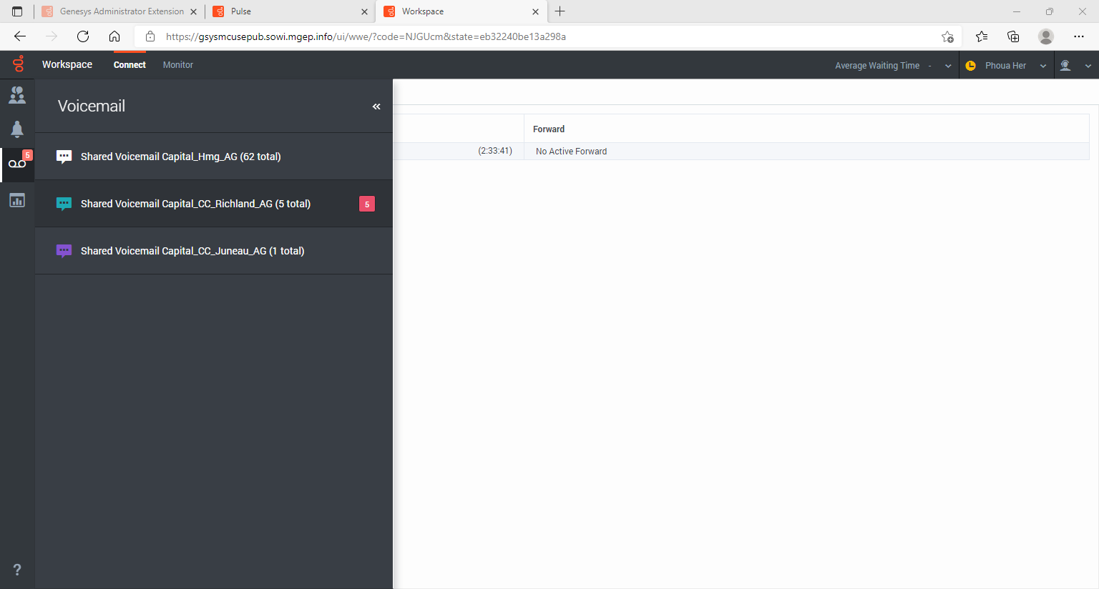

When you see there is Hmong Queue voicemail waiting to be picked up (shown above), listen to and call back the customer using the instructions below:

* *You will see a voicemail number waiting in* ***bold red****, like the Richland screen shot example above,*
* *Click on the number and it will dial your phone for you to listen to during your CCC time.*
* *Genesys will ask for PASSWORD code. Enter this code: 32050 for Hmong voicemail.*
* *Once you have listened to the voicemail, if the voicemail:*
* *Is a hang up, no further action is needed.*
* *Is not understandable but you can tell they left some sort of message, try to call the number you can view from Genesys connection ID to connect with the customer.*
* *After you listened and handled the* ***bold red*** *voicemail, DO NOT delete it off. The monitor team will delete all messages that are no longer in* ***bold red*** *on a weekly basis to start a whole new clean week.*

NOTE: Be aware that as soon as you clicked on the **bold red** number voicemail, it will no longer stay as **bold red** even if you didn’t listen to it. If you clicked on it, you MUST finish listening to it and follow the instructions listed above to complete this call properly.