Changing the Agent Phone Number in Genesys
This process changes the number in Genesys to allow an agent to take inbound calls and make outbound calls from the phone number it is switched to

Process
- Log into Genesys
- In the Genesys Workspace, you will see your name and one of the two numbers associated with your account
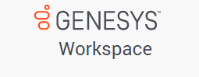
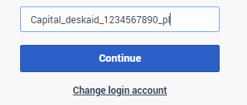

- Using the cursor, click on the agent number and delete it

- Type in your other agent number and click continue
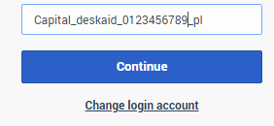

Important Notes
The phone number entered must be
- 10 digits
- No spaces, dashes, parentheses
- One of the two agent numbers that has been assigned to your Genesys account

If you have any problems with changing your agent phone number, please email the Genesys Monitoring Team at
HSEACCMonitoringTeam@countyofdane.com

November 23, 2021

