How to identify an Expedited issuance vault card vs. just a replacement vault card:

First, check which cards are vault cards and which are permanent cards:
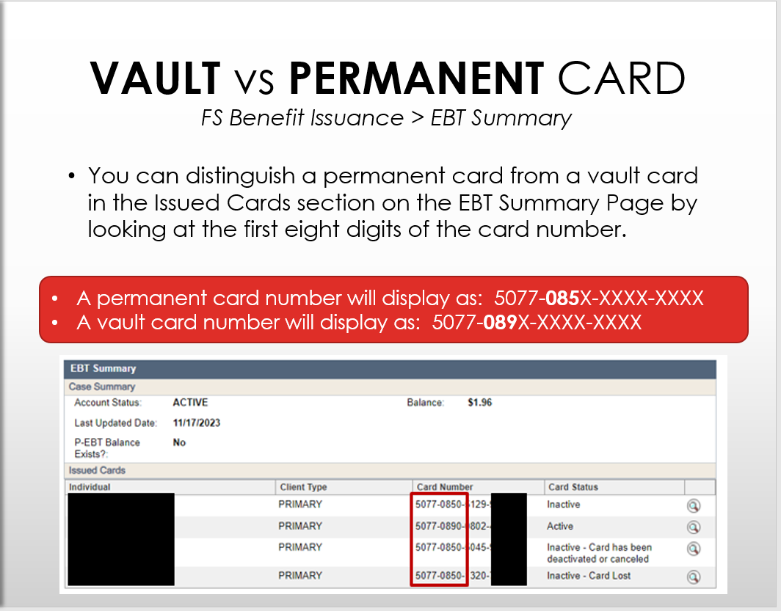

Then on the case in CWW, check the Issuance History under FS Benefit Issuance. On this screen in the column marked “Issuance Method” it will say either EBT issuance, or EBT Emergency. EBT emergency means that the benefit was issued through expedited issuance and a card issued that month should not count toward the one card per year limit. You can also confirm this by checking the past case comments.
