Should I FULLY DELETE or MARK OTX?

Please note: There is a different process for children who have been placed outside the home in Foster Care or Kinship Care. If you are unsure which process to apply, please ask a lead or supervisor for assistance.

How to FULLY DELETE:
Navigate to the HH members page - 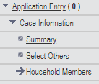
Select the correct person and click Go -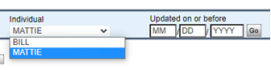
Click the ‘Delete’ box and choose the correct reason (Most common is LC) -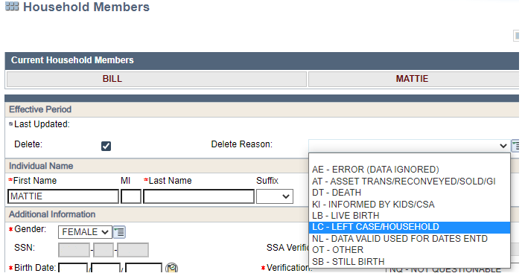
Complete driver flow and make sure you update the following pages for those remaining in the household if applicable:
Current Demo – Is a married person now divorced/widowed/separated?
Absent Parent – Did a parent leave the home and should now be referred to Child Support?
Tax Filing Information – Has there been any change to who files or is being claimed on taxes?
FS Work Registrant / ABAWD Info – Has there been a change to someone’s exemption status?

Once eligibility has been determined please confirm ALL programs and check the Case Member History page to ensure the person(s) are fully deleted. If there is NO date in the “Deleted Date” column they have not been fully removed and this will cause issues in any other case they may be a member of now or in the future. - 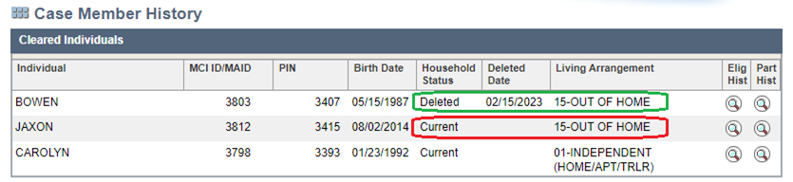
Check for other cases the deleted person may be listed on using the “Part Hist” magnifying glass and correct the living arrangement/run elig. - 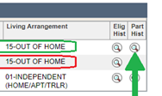
MAKE CASE COMMENTS ON ALL CASES YOU TOUCHED
How to MARK OTX:
Navigate to Current Demo – 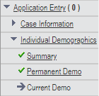
Select the correct person and click Go - 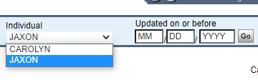

Update the following fields on the “Living Arrangement Information” section of the Current Demo page for the individual who left the home:
Begin month – Current month
Is this individual a tax dependent or tax co-filer living outside of the household? – YES
DO NOT UPDATE THE “Living Arrangement Type” FIELD. Leave this as 01, 10, etc. DO NOT MARK 15
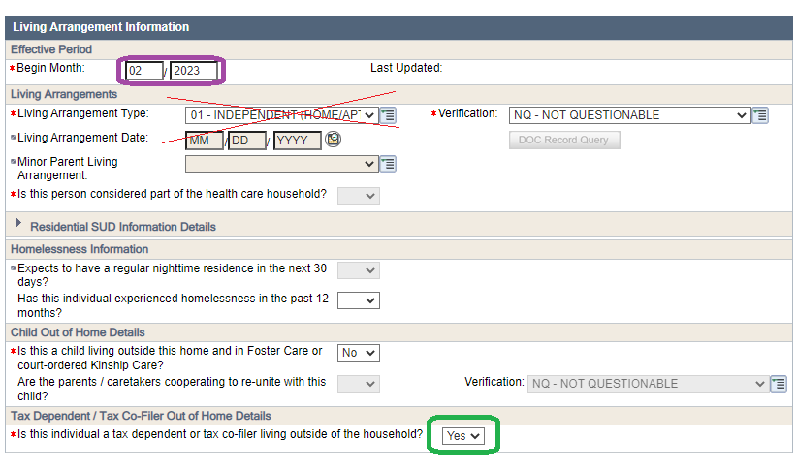

Complete driver flow and make sure you update the following pages for those remaining in the household if applicable:
Current Demo – Is a married person now divorced/widowed/separated?
Absent Parent – Did a parent leave the home and should now be referred to Child Support?
Tax Filing Information – Has there been any change to who files or is being claimed on taxes?
FS Work Registrant / ABAWD Info – Has there been a change to someone’s exemption status?

Check for other cases the OTX’ed person may be listed on using the “Part Hist” magnifying glass and run eligibility if needed -

MAKE CASE COMMENTS ON ALL CASES YOU TOUCHED

