Temporary QUEST (Vault) Card

Issuance Procedures

All policies and processes around issuing temporary QUEST cards (vault cards) have been reviewed and updated to ensure that practices across all agencies are consistent and equitable.

NEW POLICY
- Agencies can provide a maximum of one temporary QUEST card per case per rolling 12-month period
Exceptions include:
  - Expedited Benefits
  - Extenuating Circumstance: unforeseen circumstance (must be approved by Lead worker)
    - Examples - card destroyed in household misfortune; fleeing domestic abuse; medically necessary
- Two (2) forms must be completed before issuing a temporary QUEST card and stored in ECF
  - Form F-02260A Completed by customer
  - Form F-02260 Completed by worker
- Temporary QUEST card can be requested by and issued to: primary person on a case, other adult food unit members, authorized buyers, alternate payees, authorized representatives, and other designated representatives that are listed in the case record

EXPEDITED FS BENEFITS
TEMPORARY QUEST CARD ISSUANCE PROCEDURES FOR:
CLERICAL
LOBBY LEAD
OCL (for TRANSLATION)
ESS ON THE PHONE OR AT THE FD
NOTES

EXPEDITED FS BENEFITS
ESS must offer FoodShare households confirmed eligible for expedited benefits the opportunity to pick up a temporary QUEST card in person the day their application is approved or the next business day if there is no active QUEST card already associated with the case.

If there is an active QUEST card already associated with the expedited case and the household states that the existing permanent QUEST card has been lost, stolen, damaged, or is otherwise inaccessible, the agency must offer the opportunity to pick up a temporary QUEST card in person.

Complete the following steps before entering a vault card number on EBT Expedited Card Issuance Page:
- Initiate eligibility in CWW.
- Review the necessary budgets.
- Complete the Expedited FoodShare Issuance page when it appears in the driver flow:
  - Enter an "X” in the Issuance Method Field.
  - "EE" will automatically pre-fill.
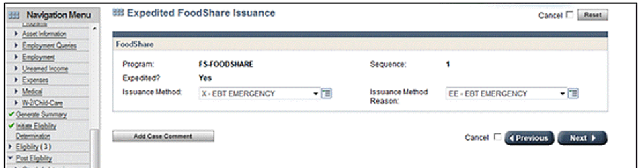
- Confirm FoodShare Benefits.
- Navigate to the EBT Expedited Card Issuance page using the link in the Navigation Menu.
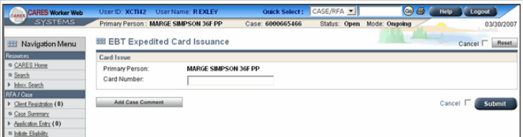
- Enter the 16 digit vault card number. The image above shows the Card Number after the Primary Persons name. When an Authorized Buyer or Alternate Payee is designated for the case, the Card Number field will display after the appropriate cardholder name.
- Click Submit.
- Click Add Case Comments to add comments to the case record.
TEMPORARY QUEST CARD ISSUANCE

CLERICAL:
- Provide customer with Form F-02260A and ask them to complete Sections 1, 2, and 3.
- Confirm that all information has been completed on Form F-02260A
- Complete Form F-02260
- Issue temporary QUEST card, if appropriate
  - If a case has already reached the limit for temporary QUEST cards and there is a possible extenuating circumstance, route to Lobby Lead.
- Assist customer with activating and setting up a PIN for the temporary QUEST card
- Case comment
  - NON EXPEDITED. Completed F-02260. Issued vault card #5077089….
  - EXPEDITED. Completed F-02260. Issued vault card #5077089….
  - NON EXPEDITED. Completed F-02260. Not eligible for vault card.
- Send both Forms to ECF

LOBBY LEAD:
- If the customer claims an extenuating circumstance, the lobby lead will
  - review the case
  - meet with the customer
  - make a determination on a case-by-case basis if there is an extenuating circumstance
  - make case comments about approval/denial of the non-expedited temporary QUEST card for an extenuating circumstance.
- If approved, the customer will be directed back to clerical for a temporary QUEST card.

OCL (for TRANSLATION):
- Take Form F-02260A with you to have it translated via Language Line
  - Complete the form with customer via Language Line
- OCL will determine eligibility for a vault card

If approved for vault card, read the following:
- “When we go to the front desk, you will be issued a temporary QUEST card. You will be asked to enter a 4-digit PIN. The PIN cannot be the same numbers or consecutive numbers. The card will expire in 30 days or when a PIN is selected for the permanent replacement card, whichever comes first. A permanent QUEST card will automatically be sent to the address on file. Once the permanent card arrives in the mail, you will have to contact QUEST Card Service to select a PIN for your new permanent card. This may be the same PIN as the one selected for the temporary card. The new permanent card will not work until activated by calling QUEST Card Service. The number will be on the back of the card. Do you have any questions?” Now we will go to the front to get your Temporary QUEST card and enter the 4-digit PIN.
- Complete Section 4 of Form F-02260A
- Escort customer to front desk to receive and PIN temporary QUEST card.

If NOT approved for temporary QUEST card, read the following:
- “You are not eligible for a temporary QUEST card. Please call QUEST to order a new card at 1-877-415-5164.”
- Complete Section 4 of Form F-02260A
- Escort customer to the lobby.

ESS ON THE PHONE OR AT THE FD:
Expedited Benefit
- If ESS confirms the household is eligible for Expedited FS Benefits, ESS must offer the opportunity to pick up a temporary QUEST card in person the day their application is approved or the next business day if there is no active QUEST card already associated with the case.
  - If there is an active QUEST card already associated with the expedited case and the household states that the existing permanent QUEST card has been lost, stolen, damaged, or is otherwise inaccessible, the agency must offer the opportunity to pick up a temporary QUEST card in person.
- Case comments must be clearly identify the benefit as EXPEDITED and that a temporary QUEST card was offered.
- Inform customer that Form F-02260A will be required to be filled out at the agency, if a temporary QUEST card is needed.

Non-Expedited Benefit
- If the customer requests a temporary QUEST card, check CWW to see if they have received one in the rolling calendar year.
  - If not, inform them they must come to the agency to complete Form F-02260A to determine if they are eligible.
  - If the customer has received one or more temporary QUEST cards in the last rolling calendar year, have them call 1-877-415-5164 to order a new card.
  - If the customer claims an extenuating circumstance, instruct them to come to the agency to complete Form F-02260A to determine if they are eligible.

Important Notes:

- Update address before issuing temporary QUEST card
- Form F-02260A and F-02260 MUST be filled out whether expedited or non-expedited.
- Forms MUST be completed at the agency
    - No mailing out forms
    - No electronic signatures
- Whenever a temporary vault card is issued to a customer, a permanent card will be mailed to the food stamp household address. When the household receives it, they need to call 1-877-415-5164 to activate the card. Calling to activate the permanent card cancels the temporary vault card. The vault card does not have the customer’s name on it and should be destroyed immediately upon activation of the permanent card.

