FS interview waiver instructions

Notes to add:

If they call in to apply/renew on CCC and have not previously sent in an ACCESS renewal/app, you will need to do a compete interview to get all their info updated and collect a telephonic signature.

Reminder C9 code no longer in effect- can’t use this like we did the first time. Need verification of wages, etc.

FDSH must have verbal confirmation to be used unless it matches the reported amount exactly (to the penny). Best practice: If all that is missing is the wages for mandatory verification and FDSH is available- When you call to reach them, try to get verbal confirmation of FDSH. If you don’t reach them leave a message that all they need to do is call the CCC to verify FDSH wages are correct, and make detailed case comments.

Examples of missing/conflicting info:

There are FDSH wage matches on the case but no employment was reported.

The person reports 0 income, but has shelter and utility costs, so how they are paying this is questionable.

Policy or Additional Information:

Effective June 26, 2023, a FoodShare interview will not be required for applications or renewals for FoodShare filed on or after June 26, 2023, if the primary person’s identity has been verified (FoodShare Handbook 1.2.3.1 Identify Verification). If there is any questionable information (FoodShare Handbook 1.2.5 Questionable Items) that can be clarified by phone with the member, IM workers must make an attempt to contact the household to obtain clarification. If the household cannot be reached for clarification and/or any other verification is required, IM workers must waive the interview and pend for the verification. The simplified reporting requirement script is not required for all waived interviews or during clarification calls.

Individuals who call in to apply for or renew FoodShare benefits are required to complete an interview. RFAs created with the minimal information to set a filing date: name, address, and signature (ex: F-16019A FoodShare Wisconsin Registration paper form or a “Page One” as listed in Process Help 2.3.1) will still require the interview in order to get the information needed to process the request(s).

**Processing Instructions:**

1. Any FoodShare Interviews that are waived must be coded as T-Telephone, and the FoodShare Hardship Reasons page **must** be coded ‘Waived Interview’.

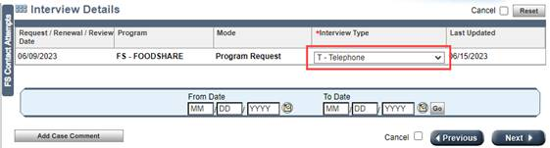

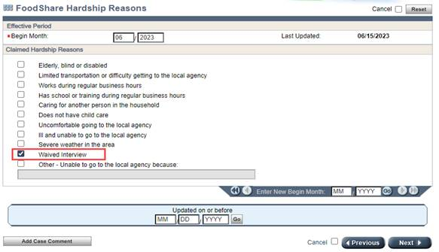

1. Process through the application/renewal, updating all screens as appropriate and querying available resources to attempt to verify reported information
2. If any verification is required, pend the case using normal processes.
3. Workers must contact the household if there is any unclear or conflicting information reported on the application or renewal that needs clarification or when more information is needed. Workers must make every attempt to verify household circumstances through data exchange matches or existing verification documents.
   1. If there is information that requires a clarification call, the worker must make 1 attempt to reach the household to obtain clarification. If the member is reached, obtain clarification needed, update the case as necessary and proceed to step 5.
   2. If the worker is unable to reach the member to obtain clarification of questionable information (including if the member has not provided a phone number), worker must pend the case for loss of contact on the General Case Summary page,

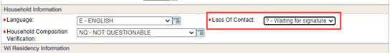

* 1. Add text to the VCL indicating what type of clarification is needed.

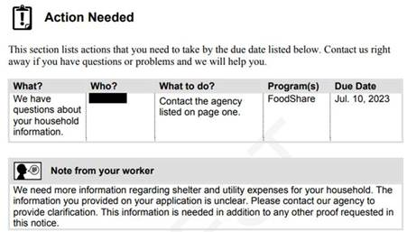

1. Workers must complete (applications) or update (renewals) the ‘FS Work Registrant/ABAWD Information’ page for each required member of the household (each required member’s name will appear in the drop-down box for ‘Individual’ on the page):

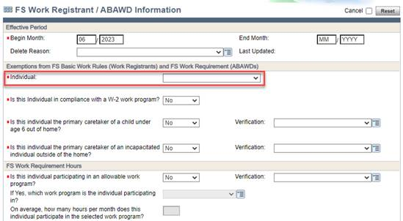

* 1. If the answer to any of the first 4 questions on the page are blank, worker must update the answers to ‘No’.
  2. If the answers are already populated with a ‘Yes’, worker must pend for verification (if not already received).

1. Worker initiates eligibility determination.
2. Worker must stop at the ‘FS Work Registrant / ABAWD Determination Details Page’ to review the results of the determination. If any member of the household is determined to be a Work Registrant and/or ABAWD, the worker must stop and make at least one attempt to reach the household to complete an exemption screening and read the appropriate script(s) (attached), based on the results of each household member’s work registrant or ABAWD determination. NOTE: This includes Work Registrants/ABAWDS who are coded as ‘Y-DE’ in the TLB Waived field.

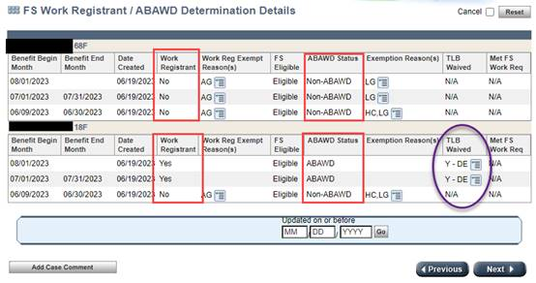

The exemption screening consists of asking the applicant or member about qualifying exemptions from the FoodShare Basic Work Rules and/or the FoodShare Work Requirement that may not be collected through the application process:

* Asking if any of the individuals are pregnant or experiencing chronic homelessness
* Asking the first 4 questions found on the FS Work Registrant/ABAWD Information page for each FS Work Registrant/ABAWD in the household:

1. Is this individual in compliance with a W-2 work program?
2. Is this individual the primary caretaker of a child under age 6 outside the home?
3. Is this individual the primary caretaker of an incapacitated individual outside of the home?
4. Is this individual participating in an allowable work program?

If after the exemption screening, any household members are still considered Work Registrants or ABAWDS, the worker must read the correct script(s) (attached) (**Note:** a copy of the FS Basic Work Rules and FS Work Requirement Script are attached).

The worker **must** document in case comments that the exemption screening was either attempted or completed and when an oral explanation(s) of work requirements has been read to the household.

In all instances, case comment a summary of the application information and document that the interview was waived.