**Reinstatement of FoodShare Work Requirement and Changes to FoodShare Work Requirement Age Range and Exemptions**

**Background:**

Under FFCRA, the FoodShare work requirement time limit was temporarily and partially suspended through the end of the month following the month the PHE ends. The PHE ended on May 11, 2023, and the federal suspension ended on June 30, 2023.

Operations Memo 23-20 Reinstatement of FoodShare Work Requirement announced the reinstatement of with work requirement for Able Bodied Adults Without Dependents (ABAWDs).  On June 3, 2023, the Fiscal Responsibility Act (FRA) of 2023 was signed into law. The FRA establishes additional exemptions from the ABAWD work requirement and changes the age range for who is subject to the ABAWD work requirement.

This messaging is to provide information about the phase in of the reinstatement of the work requirement, as well as processing instructions for the changes announced with the FRA.

**Policy Information:**

The FRA added new ABAWD exemptions for veterans and Former Foster Care Youth and expanded the definition of the homeless exemption. It also changed the age range for who is subject to the FoodShare Work Requirement for ABAWDs. Verification requirements for exemptions are also changing.

The FRA guidance documents clarify that exemptions are not required to be verified unless questionable. This verification policy applies to all exemptions from the FoodShare work requirement for ABAWDs. Reference Operations Memo 23-26 Changes to FoodShare Work Requirement Exemptions and Age Range Based on the 2023 Fiscal Responsibility Act.

Currently ABAWDs include those aged 18-49. The age range will be increased over 3 federal fiscal years.

* Fiscal Year 2023: 18 – 50 years of age (starting September 1, 2023)
* Fiscal Year 2024: 18 – 52 years of age (starting October 1, 2023)
* Fiscal Year 2025: 18 – 54 years of age (starting October 1, 2024)

**Additional Information:**

***FOODSHARE WORK REQUIREMENT FOR ABAWDS PHASE IN PLAN***

The FoodShare work requirement for ABAWDS time limit policy was reinstated effective July 1, 2023, and began a nine-month phase in period. By the end of the phase in period, all FoodShare members and applicants who are considered ABAWDS will have to be meeting the work requirement or have an exemption to avoid getting a Time Limited Benefit (TLB). During the phase in period, applicable members will be notified in advance of needing to meet the work requirement.

The current phase in plan is as follows:

* All individuals determined to be ABAWDS are receiving a systematic exemption for July, August, and September 2023.
* All **new** Foodshare applicants with a certification period beginning on or after October 1, 2023, will be subject to the time limit, if applicable.

Note: The time limit will not apply to members ages 50-52 at this time. They will be phased into the work requirement on a separate schedule. When a member needs to meet a work requirement, they will get a letter telling them this. Further details on how the expanded age range will be phased in will be provided when the CARES updates are completed.

|  |  |
| --- | --- |
| Example 1a | Sarah A applies for FoodShare in September 2023. Sarah A is an ABAWD; however, because of the delay in rolling out the work requirement, Sarah will receive an exemption in September 2023 and every month going forward until her next renewal or SMRF.  Note: CWW will be systematically updated to correctly apply these exemptions. Workers do not need to take any action. |
| Example 1b | Sarah B applies for FoodShare in November 2023. Sarah B is an ABAWD and will be subject to the ABAWD time limit at the time of application. (This will be true if Sarah B applies any time after October 1, 2023.) |

* The time limit will apply to applicable **ongoing** members beginning the first month following their next renewal or six-month report form, starting with renewals and SMRFs due in September 2023.

|  |  |
| --- | --- |
| Example 2a | Axel is a FoodShare member with a SMRF due in August 2023 and a renewal date of February 2024. Axel is an ABAWD. Axel will not become subject to the time limit after his SMRF, since his SMRF is due in August. Instead, he will become subject to the time limit in March 2024, after he completes his renewal due in February.  Note: CWW will be systematically updated to correctly apply these exemptions. Workers do not need to take any action. |
| Example 2b | Kyle is a FoodShare member with a SMRF due in September 2023 and a renewal due in March 2024. Kyle is an ABAWD. He completes his SMRF timely and his FoodShare eligibility continues. Kyle will become subject to the time limit beginning in October 2023. |

The correct FoodShare oral explanation script(s), the FoodShare Basic Work Rules and/or FoodShare Work Requirements Script, will be scheduled as appropriate at application and renewal.

***CHANGES TO FOODSHARE WORK REQUIREMENT AGE RANGE BASED ON THE 2023 FISCAL RESPONSIBILITY ACT PHASE IN PLAN***

The first age increase, for Federal Fiscal Year 2023, will only impact September 2023. For that one month only, ABAWDs will include those up to 50 years old (not 49). Because of our ABAWD time limit reinstatement plan, all ABAWDs, including the new group of 50 years old’s, will not receive a TLB for September 2023. The Department of Health Services (DHS) will be updating the policy to reflect that as of September 1, 2023, the age range for ABAWDs is 18-50, but will not be doing any external messaging directly to members specifically for this one month since it does not impact benefits.

Workers are not required to make any updates to FoodShare clocks related to the age range changes at this time. CARES updates will be implemented to systematically apply ABAWD policies to applicants and members between the ages of 18 and 52. The updates are scheduled for the October 2023 CARES release. Further details on how the expanded age range will be phased in will be provided when the CARES updates are completed.

**Processing Instructions:**

Effective August 14, 2023, workers must follow the temporary process outlined below to screen all potential ABAWDS for applicable exemptions. This includes any FoodShare members currently aged 18-52, to ensure that if/when a FoodShare member is phased in to the work requirement, they have been screened for any possible exemption. Workers must enter case comments indicating that a temporary manual process was followed until CARES updates can be made.

**Updating case when pregnancy is a reported exemption:**

If a member reports a pregnancy and the report is not deemed questionable, workers must:

* Update the Pregnancy page using ‘CC – Collateral Contact’ as the verification code, and
* Enter the date the pregnancy was reported in the “Pregnancy Verification Date field.”

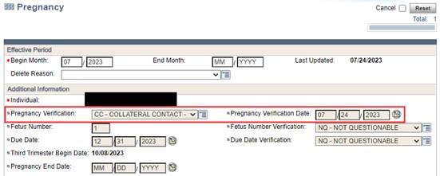

**Applying new/expanded exemptions:**

If a member indicates they are experiencing homelessness, workers must:

* Update the Current Demographics page to reflect a Living Arrangement Type of ’10 – Homeless’, and
* Update the Homelessness Information section to answer the question “Expects to have a regular nighttime residence in the next 30 days?” question to ‘No’.
  + Note: this action must be taken even if the member has responded “Yes” to this question to ensure the exemption is applied.
* Document the action in the case comments.

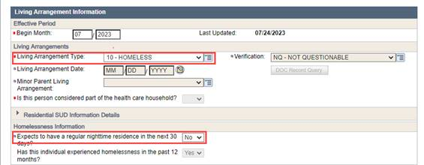

When workers reach the FS Work Registrant / ABAWD Information page in the driver flow, in addition to the questions listed on the page, workers must ask:

1. Has this member ever served in the United States Armed Forces (including the Army, Marine Corps, Navy, Air Force, Space Force, Coast Guard, National Guard, and Armed Forces Reserve) and been discharged or released under any condition?
2. Was this member in foster care on their 18th birthday and currently under 25 years of age?

If the answer to either of these questions is ‘Yes’, the worker must:

* Answer the “Is this individual the primary caretaker of a child under age 6 out of the home” question on the page with a ‘Yes’ and,
* Enter ‘CC – Collateral Contact’ in the Verification field.
  + Note: Information indicating that the member is the primary caretaker of a child under the age of 6 out of the home will show on the case summary sent to the member. DHS recommends explaining to the member that the case has been temporarily updated with this information to grant them the exemption they are entitled to at this time and will be updated when system enhancements are completed.
* Document in the case comments what the actual reported exemption is and that the temporary manual process was followed.

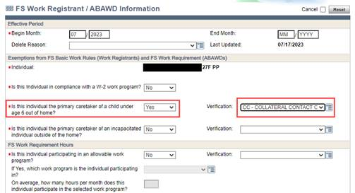

Examples of case comments:

|  |
| --- |
| * “Screened PP for all work registrant and ABAWD Exemptions, including homelessness, former foster care youth and veteran status. PP reported no exemptions.” * “Screened PP and spouse for all work registrant and ABAWD exemptions, including homelessness, veteran and former foster care youth status. Reported spouse is a veteran. Updated FS Work Registrant/ABAWD Information page to indicate spouse is the primary caretaker of a child under age 6 outside of the home, per temporary manual process. Explained to PP this will show on the case summary and is only temporary, until system updates are completed.” |

DHS will provide Income Maintenance (IM) and Tribal agencies a report of members who may qualify for an exemption based on information already in CARES (i.e. receiving Veteran’s benefits, homeless, etc.) to be reviewed and have the manual process applied, if appropriate, prior to Adverse Action in September 2023. This will allow the exemptions to be applied based on existing information in CARES without requiring the member to report it.

After CARES has been updated, DHS will provide an additional report of members who received an exemption through a manual process for workers to review and update as needed. Further information and instructions will be provided when these reports are available.