Scenario #1 – Act or Hold?
Document received via CDPU (scan first). No other information provided other than what you see below. No data exchange information available to add further context. KWIK TRIP has not been reported until receipt of today’s document.


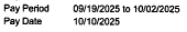
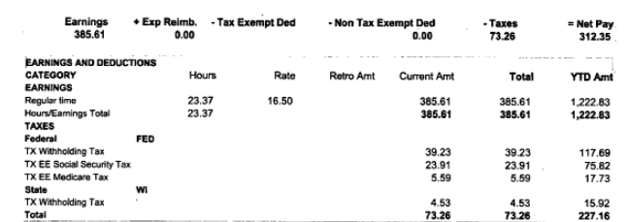

Scenario #2 – Act or Hold?
Document received via CDPU (scan first). One paystub provided along with a written UCOR. KWIK TRIP has not been reported until receipt of today’s documents.

“My spouse has returned to work – here is her most recent paystub and she expects to work at least 19 hours per week. If there’s anything else needed, please let me know!”

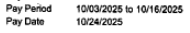
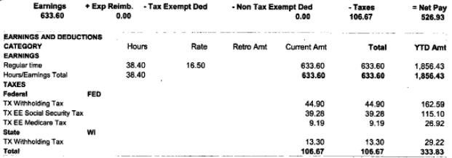

Scenario #3 – Act or Hold?
Primary Person (PP) contacts the agency via Capital Call Center. PP reports that his wife is working at Kwik Trip. Because there is a HC request on the case, you are able to pull FDSH data for this job. PP agrees that FDSH data is accurate.
