When a customer contacts the agency because they received a letter telling them to renew their HC. It is possible they are receiving HC in iC only. This population may not be eligible under current requirements, but since they are to remain eligible until the next household health care renewal; they need to reapply and we need to reopen their eligibility until the CEED.
Tip #1
- Case must be open on CWW for other household members. You will not see the iC letter in ECF
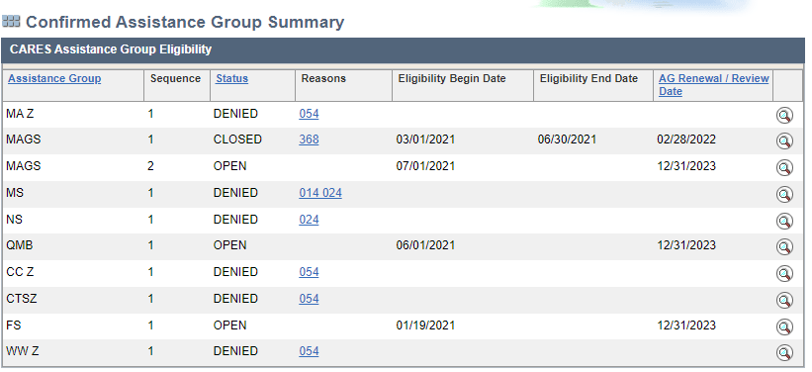
- Check for a member’s eligibility ending during March 2020-May 31, 2023. Their eligibility closed during the pandemic.
Tip #2

MAGS EXAMPLE
Remember the customer must be calling to re-apply for HC benefits
Ask which member received the letter and check each HC category.

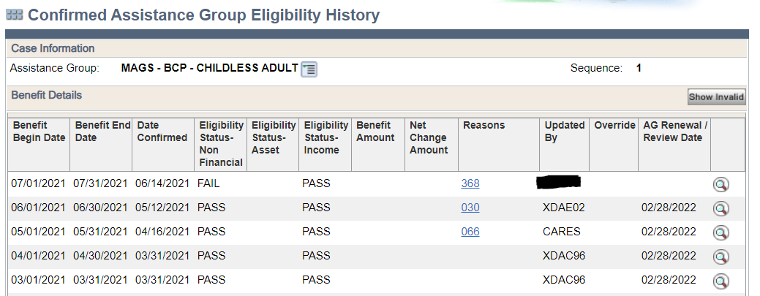

Click on magnifying glass to see eligibility

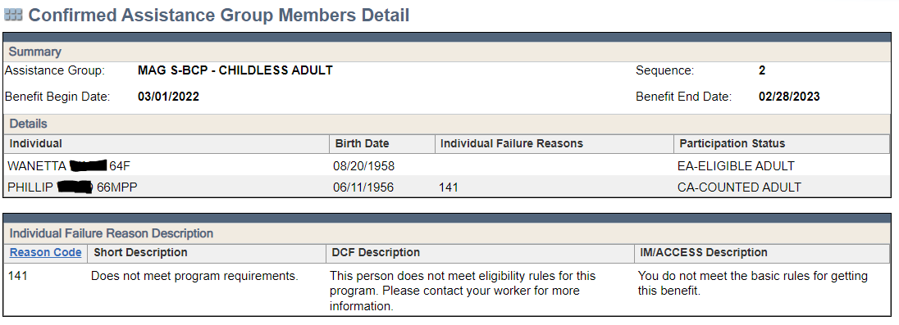

- Check Health Care Continuous Eligibility Tracking.
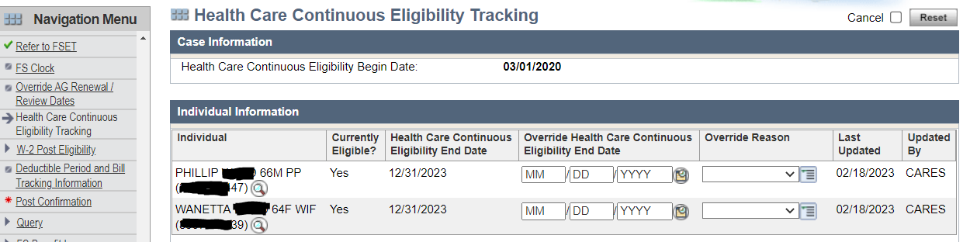

CARES PIN—used this to lookup the member up in iC

- Email the PRT to inquire if the person is part of the list of individuals for whom we must extend eligibility. If PRT tells you the person is eligible, try to do a workaround to re-open the case. The workarounds are not always possible in CWW. It is easier to extend eligibility directly in iC to match the CEED.
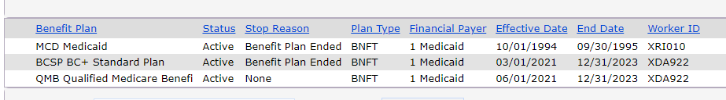
This shows the eligibility extended to CEED

- Send manual positive notice to household.

- Case must be open on CWW for other household members. You will not see the iC letter in ECF
Tip #1
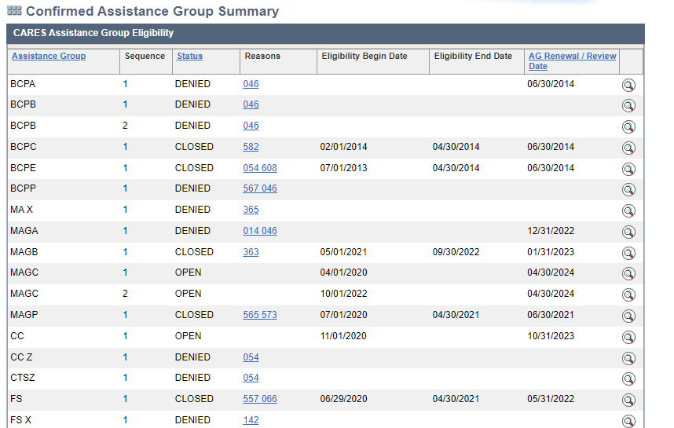
- Check for a member’s eligibility ending during March 2020-May 31 2023. Their eligibility closed during the pandemic.
Tip #2

MAGP EXAMPLE
Remember the customer must be calling to re-apply for HC benefits

Ask which member received the letter and check each closed HC category.

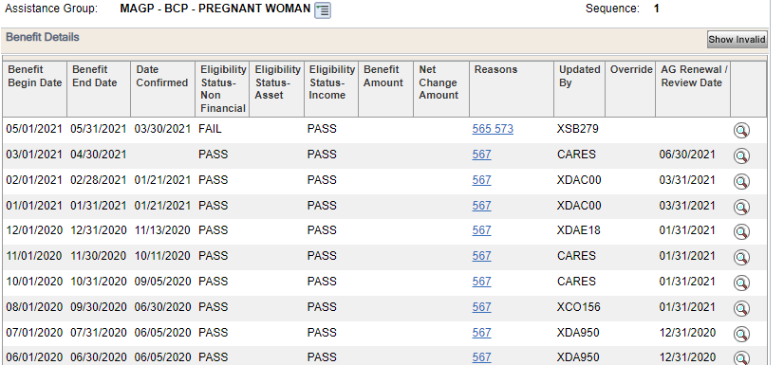
Click on magnifying glass to see eligibility

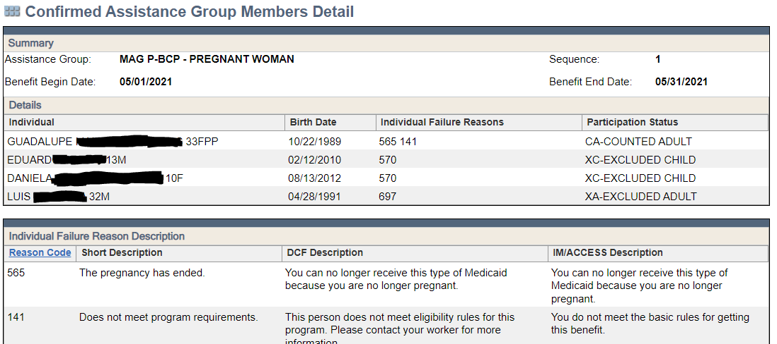

- Check Health Care Continuous Eligibility Tracking.
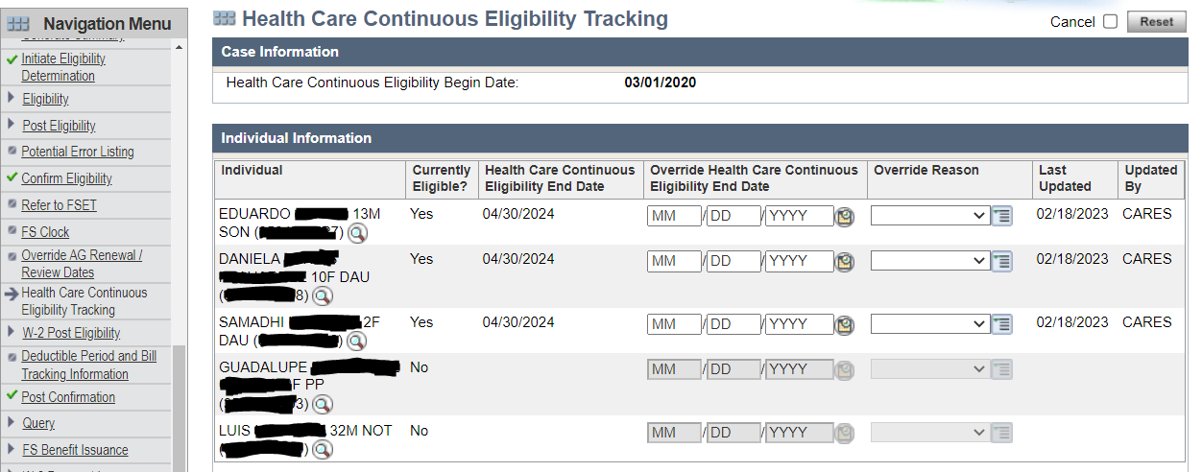

CARES PIN—used this to look the member up in iC

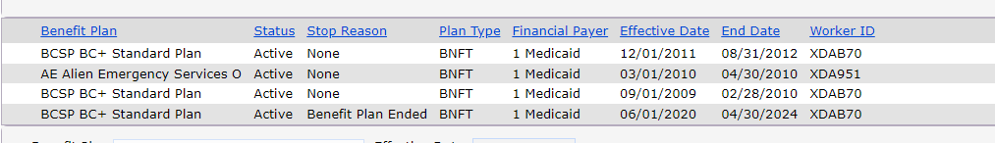
- Email the PRT to inquire if the person is part of the list of individuals for whom we must extend eligibility. If the PRT tells you the person is eligible, try a workaround. The workaround is not always possible in CWW (MAGP—requires to enter a new pregnancy screen).It is easier to extend eligibility directly in iC to match the CEED.
This shows the eligibility extended to CEED

- Send manual positive notice to household.

