# Daily Timeliness Reports

In order to ensure that you are processing all cases coming due in a timely fashion, you must check both your CWW Caseload Management Report and your Mainframe Alerts daily. In addition, monitor your dashboard for Applications, Renewals and SMRFs coming due.

# CWW Caseload Management Report

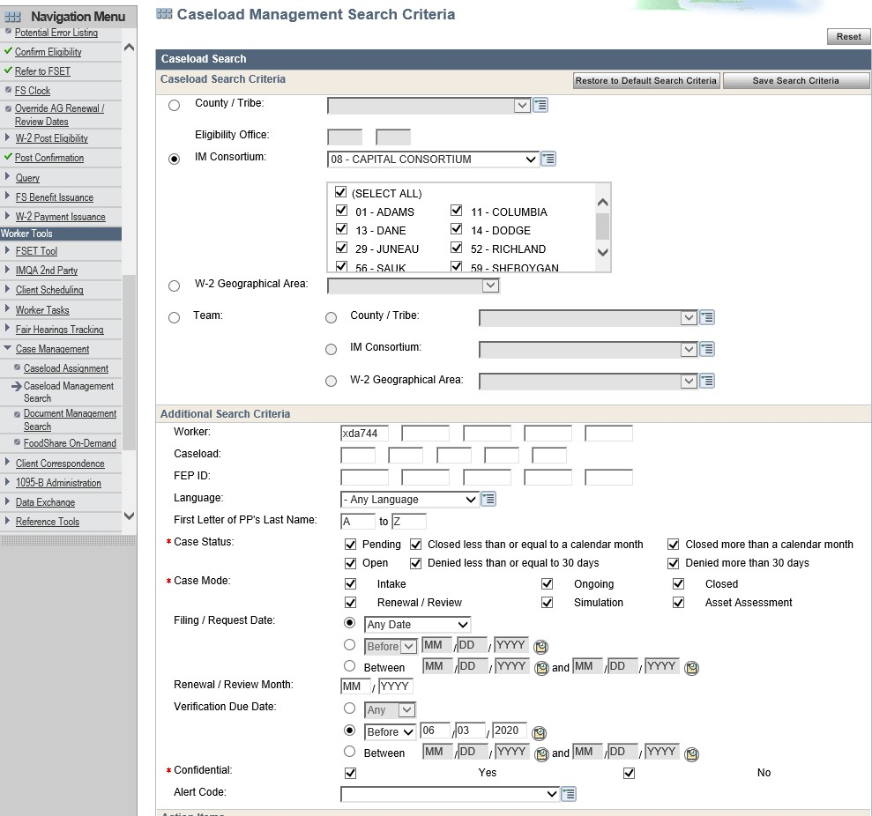

Enter tomorrow’s date in the Verification Due Date Field. If today is a Friday, enter Monday’s date.

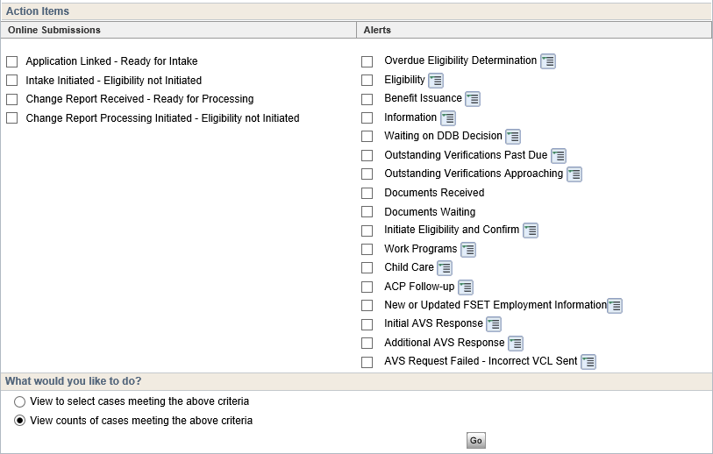

Leave this section without checkmarks. This will ensure that you received all cases which are due on your report.

Now process all cases on your report. If the case is only due for W2, email the W2 worker so that they can update the case as appropriate.

# Mainframe Alerts

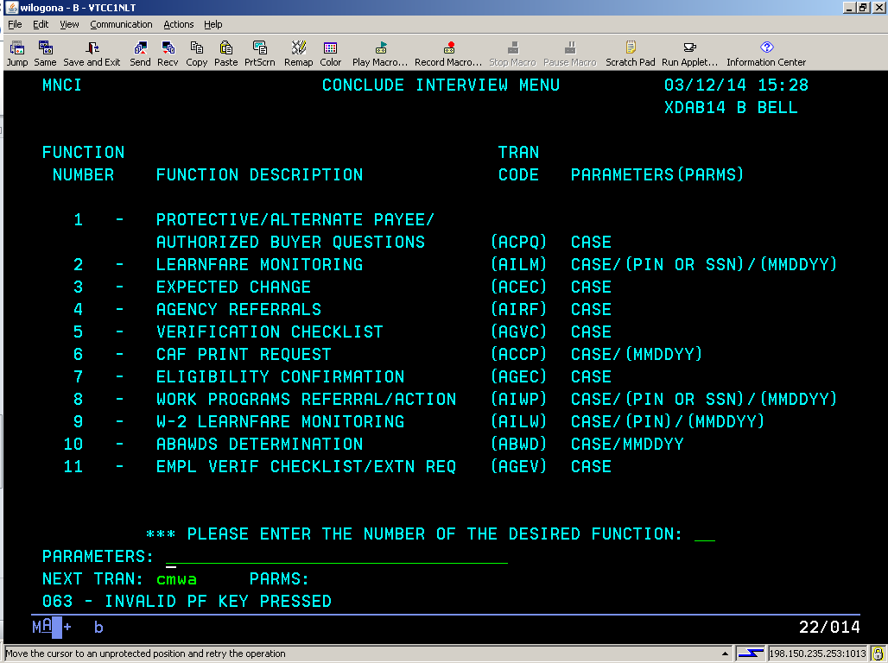

Navigate to CMWA in Mainframe, no parameters

This will generate your list of alerts to work on. You should process all alerts with today’s date or earlier in the Date Due Field. Pay special

attention to BC Late Premium Alerts, and process these right away.

Clean up your alerts that do not require action each day. This will keep you from getting behind or swamped with alerts.

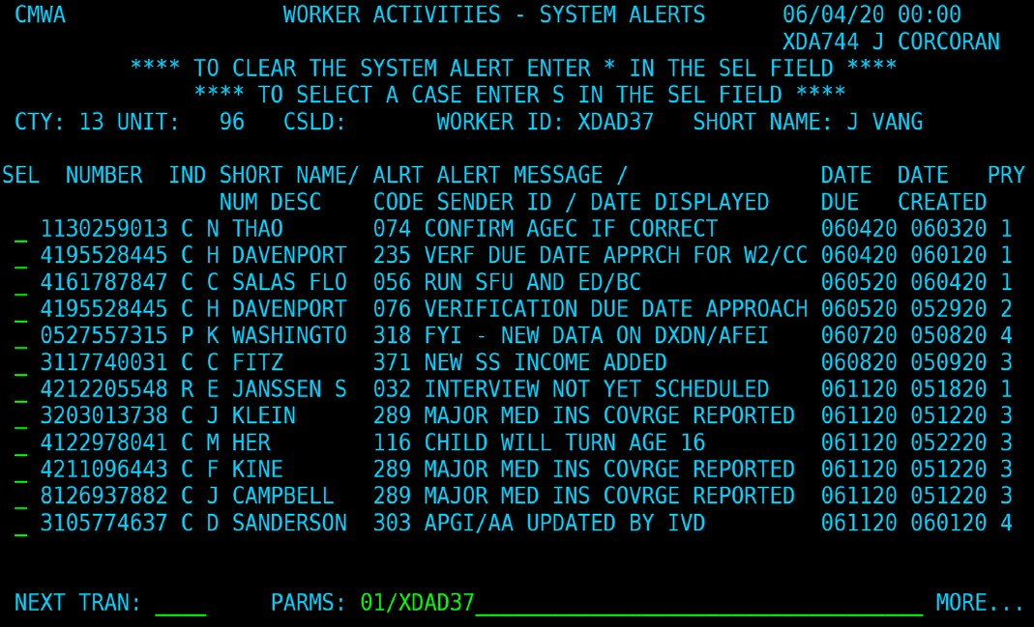

You can sort by alert number by navigating to CMCR in Mainframe and entering the alert code you would like to view. This will generate a list of all cases with this alert code, and may make it easier for you to

manage your alerts.

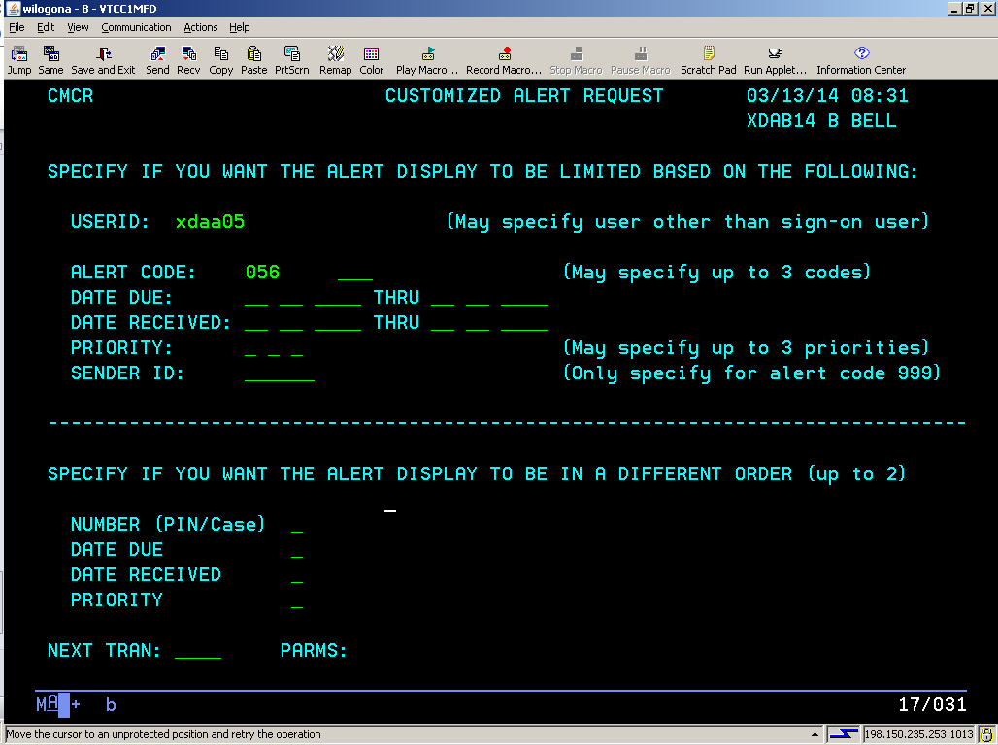

# Dashboard

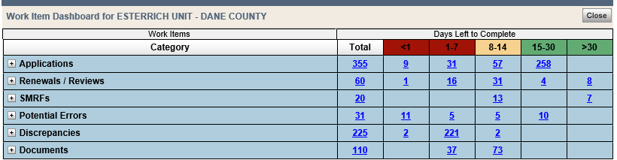

All Applications, Renewals, SMRFs, Discrepancies, and Documents in the <1 (less than 1) day column must be updated each day.