LISTS

One day absences –
- 7/10/30 day list needs to be completed. Please check all three places.
  - Caseload Management
  - Worker’s dashboard, and
  - Mainframe alerts due that day.

2+ absences –
- 7/10/30 day list; documents, changes, SMRF’s, and renewals to within 2 days; and HC apps on the Workload Report need to be completed.
- Complete everything that you would for a 1 day absence.
- Go to the Document Management Search to check for documents that were received 2 business days prior. For example, today is 11/04/22 and we are working on 11/01/22. Enter the worker’s X ID, and select the option to view the documents received before 11/02/22 to ensure that nothing is missed.
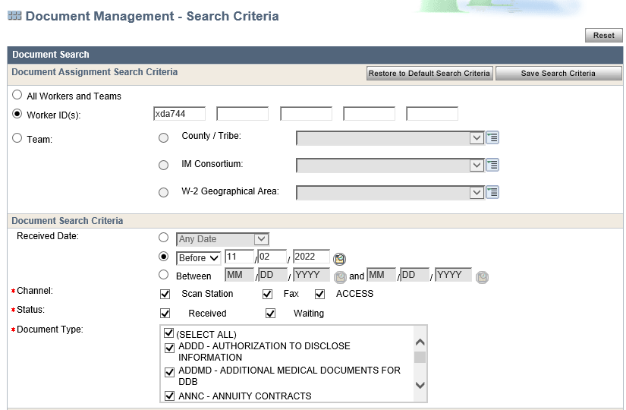

- Process Changes using the Inbox Search.
- Look at the worker’s dashboard and process any SMRF’s or Renewals received on the date that we are working on.
- Process HC applications that are listed on the Workload Report for the absent worker. These should be processed the day that they show up on the report.

Reminders –
- If a worker is out 2+ days and is behind, we should first work the items for the day that we are assigned, and then work any older items, as time permits. If you are unable to complete the older items, please email the Capital Leads to ask for help by 2PM.
- For 1 day absences, only the verification due and mainframe alerts due that day need to be completed. Late renewals and SMRF’s do NOT need to be processed.

