Alerts Desk Aid
May 2020

Reference Sources:

- Process Help, Section 43 Alerts: /process_help/e43/43.htm
- Action Items: /process_help/e43/43.2_action_items
- Process Help, Section 44.6 Appendix A, Alert: /process_help/e44/44.7_appendix
- DHS/DMS/BEPS New Worker Training OCM Basics: Alerts

Alert Help Text:
- (CWW) Worker Tools/Reference Tools/Alert Code Help Text Search (or)
- (CWW) Under Action Items on the case, click the magnifying glass to the right of the Alert (or)
- (Mainframe) Type CUAH in the NEXT TRAN field and enter 3 digit alert code in the PARMS (or)
- (Mainframe) Enter # in the field in front of the alert when on CMWA, press enter (or)
- (Process Help) Use key words associated with the Alert in question to search Process Help (i.e. searching the alert number or the partial or full title of the Alert can lead to PH explanation of the alert)
**TIP** How to “search” in Process Help: Use Google Chrome as PH search function does not work with Internet Explorer. Copy this link: https://prd.cares.wisconsin.gov/help/ph/ph.htm

***Some Alerts do not have the Help Text: BSX HELP TEXT NOT AVAILABLE FOR THIS ALERT CODE. If nothing in help text, check Process Help 44.6, Appendix A. If there aren’t any instructions in PH 44.6, then use the Search option in PH. If the alert does not have help text and is not found in PH, See CARES Alert Table (Page 3 below). If still needing help, reach out to PRT/Lead for further instruction on how to process the specific alert.

Customized Alert Search:
- (Mainframe) Enter MNSA in TRAN field, Select #11 Customized Alert Request or
- (Mainframe) Tran directly to CMCR (pictured below)
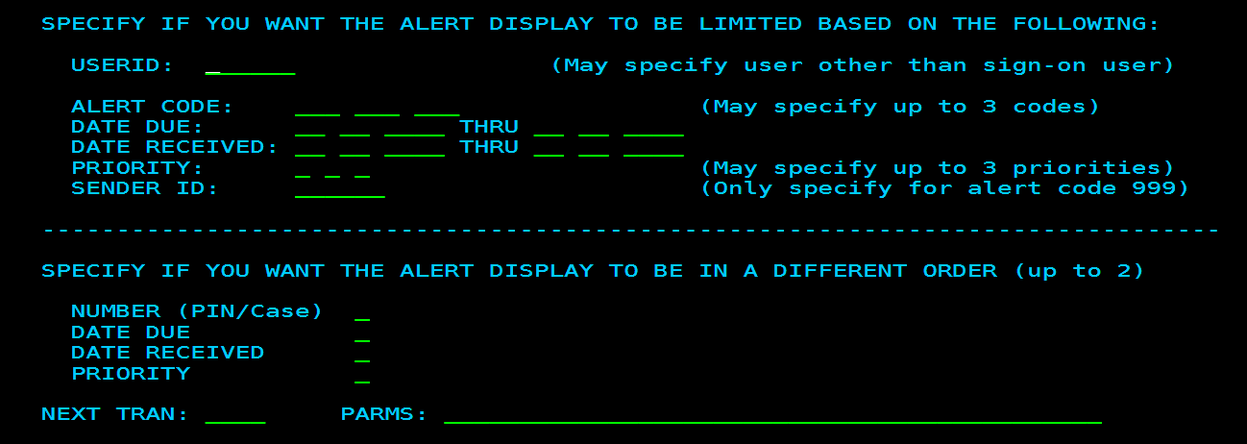

**TIP** Prioritize alerts: #1 and #2 most critical to work, #3 and #4, many are FYI/informational

CWW Case Management Search Criteria:
- Worker Tools/Case Management/Caseload Management Search Criteria
You must review CMWA even if you are searching Alerts in CWW. Not all Alerts are viewable in CWW.
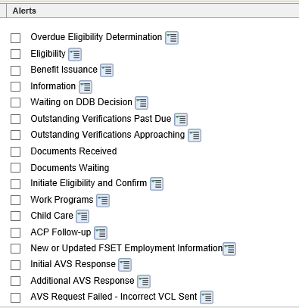
**Search based on the type of alert you want to work. Search on cases that have alerts belonging to the following categories. For each of the alert groupings, except for document-related, you bring up a listing all alerts associated with the alert group.

CARES Alert Table (see attached)

The list attached is for common alerts without help text or with vague help text. Supplemental clarification is found on the attached table on how to process such alerts.
ALERT CODE ALERT DESCRIPTION |  | HELP TEXT? | PH? | Supplement Text
56 | RUN SFU AND ED/BC | Yes | Yes | If benefits change/reduce, check for 15'd living arrangement, changes to income, changes to expenses. Possible  companion case? Do NOT just run eligibility and confirm. Review case first.
105 | DISABILITY/INCAP REV DUE | Yes | No | Use MEH 5.7 for guidance. Client is due for DDB re‐determination. Check Diary Date on Disability page. Note that  if client is now found disabled through SSA (ex. SSDI, SSI), then clear the Diary Date and DDB re‐determination no longer needed.
106 | DISABILITY/INCAP REV PAST DUE | No | No | Use MEH 5.7 for guidance. Client is due for DDB re‐determination. Check Diary Date on Disability page. Note that if client is now found disabled through SSA (ex. SSDI, SSI), then clear the Diary Date and DDB re‐determination no  longer needed.
110 | PREGNANCY PAST DUE | Yes | No | Review case, was newborn added but pregnancy page not updated? Since pregnancy overdue, enter in  pregnancy end date, run and confirm case
113 | EDUCATIONAL AID EXPIRES | Yes | No | Run and Confirm case. Do not pend case for ongoing Educational Aid. It is on the client to report if new  educational aid received.
128 | CP ADDRESS CHANGE.SEE KIDS AAA | No | No | KIDS Path 2, 1, 4. Update address as needed. If CC on case, may need to pend for verification of new address.
189 | CHILDREN FIRST BEGINS | No | No | Review FS Handbook 3.17.1.7 . Particpating in this program can help client meet ABAWD requirements
233 | DRUG FELON 12 MTH PERIOD EXPD | No | No | Review FS Handbook 3.20.1.3. 12‐month drug felon sanction expired.
242 | SSI VERIFIED/SEE DXSX | Yes | Yes | Add a disability page entry if one is not already on the case
243 | WTPY TITLE II DATA/SEE DXSA | Yes | Yes | Check to make sure income in SOLQ matches the income in CWW. Check Medicare A/B screens and make sure  they reflect the clients MSP status correctly.
255 | SSI ENDING CHECK ANDI | Yes | Yes | Use MEH 5.3.6.1 for guidance.
289 | MAJOR MED INS COVERAGE REPORTED | Yes | No | Review new hire in employment query. If there is a new job, add it &? for verification. If no new hire run  eligibility to determine whether or not BCP/MA will be affected.
303 | APGI/AA UPDATED BY IVD | No | No | Check the AP page for updates. If AP has same address as the PP, check KIDS for notes or details regarding that address. If address appears current, and KIDS has notes regarding the address, pend HH comp or add AP?,  request verification and create a BRITS referral.
304 | NEW AP FROM IVD ON IVDI/DE | No | No | Check AP Page for updates. If AP is in the home, check household relationships. May need to add a Claimed  Father to FS.
305 | NEW PATERNITY IND ‐ SEE APGI | No | No | Check AP Page for updates. If AP lives in home, update household relationships.
502 | NON‐CEN TURNING 1 INC>200% | No | No | BC+ Handbook 19.1. Children's premiums start at 201% FPL ‐ run case to see if premium is now needed for this  child
530 | ADMIN RNWL CASE SUMM FAILED | No | No | Generate Summary, then select “electronic” and then “mail summary”
533 | NEW/UPDATED FSET EMPLOYMENT | Yes | Yes | Possible Employment. Search CWW with client's PIN. Then view appropriate FSET Information pages.
560 | IMM VER ROP DUE: RUN ELIG. | No | No | BC+ Handbook 4.2.4.4. MEH 7.2.4.4. 95 days for Cit/ID has expired. Run/Confirm case.
561 | SSN APP DATE GREATER THAN 6 MO | No | Yes | CC Handbook 1.3.6. CTS Handbook 3.1.12. Need SSN for newborn. Check KIDS for SSN, otherwise pend case.
242 SSI VERIFIED/SEE DXSX  243 WTPY TITLE II DATA/SEE DXSA  319 FYI‐SSI AMT/RECOUP UPDATED  370 FYI SS INCOME UPDATED  371 NEW SS INCOME ADDED  381 MEDICARE INFO END DATED  382 SS INCOME END DATED |  | Yes YesYes Yes Yes Yes  Yes | Yes Yes Yes Yes Yes Yes  Yes | While many Social Security and Medicare Alerts are listed as FYI by the State, it is recommended that you double‐ check the case entries for accuracy before running/confirming and/or deleting the alert.

