FSET Employment Plan (EP)
How do I locate the FSET EP?
FSET participation is tracked at the per-person level. That means you need the person’s PIN # to search for their EP.
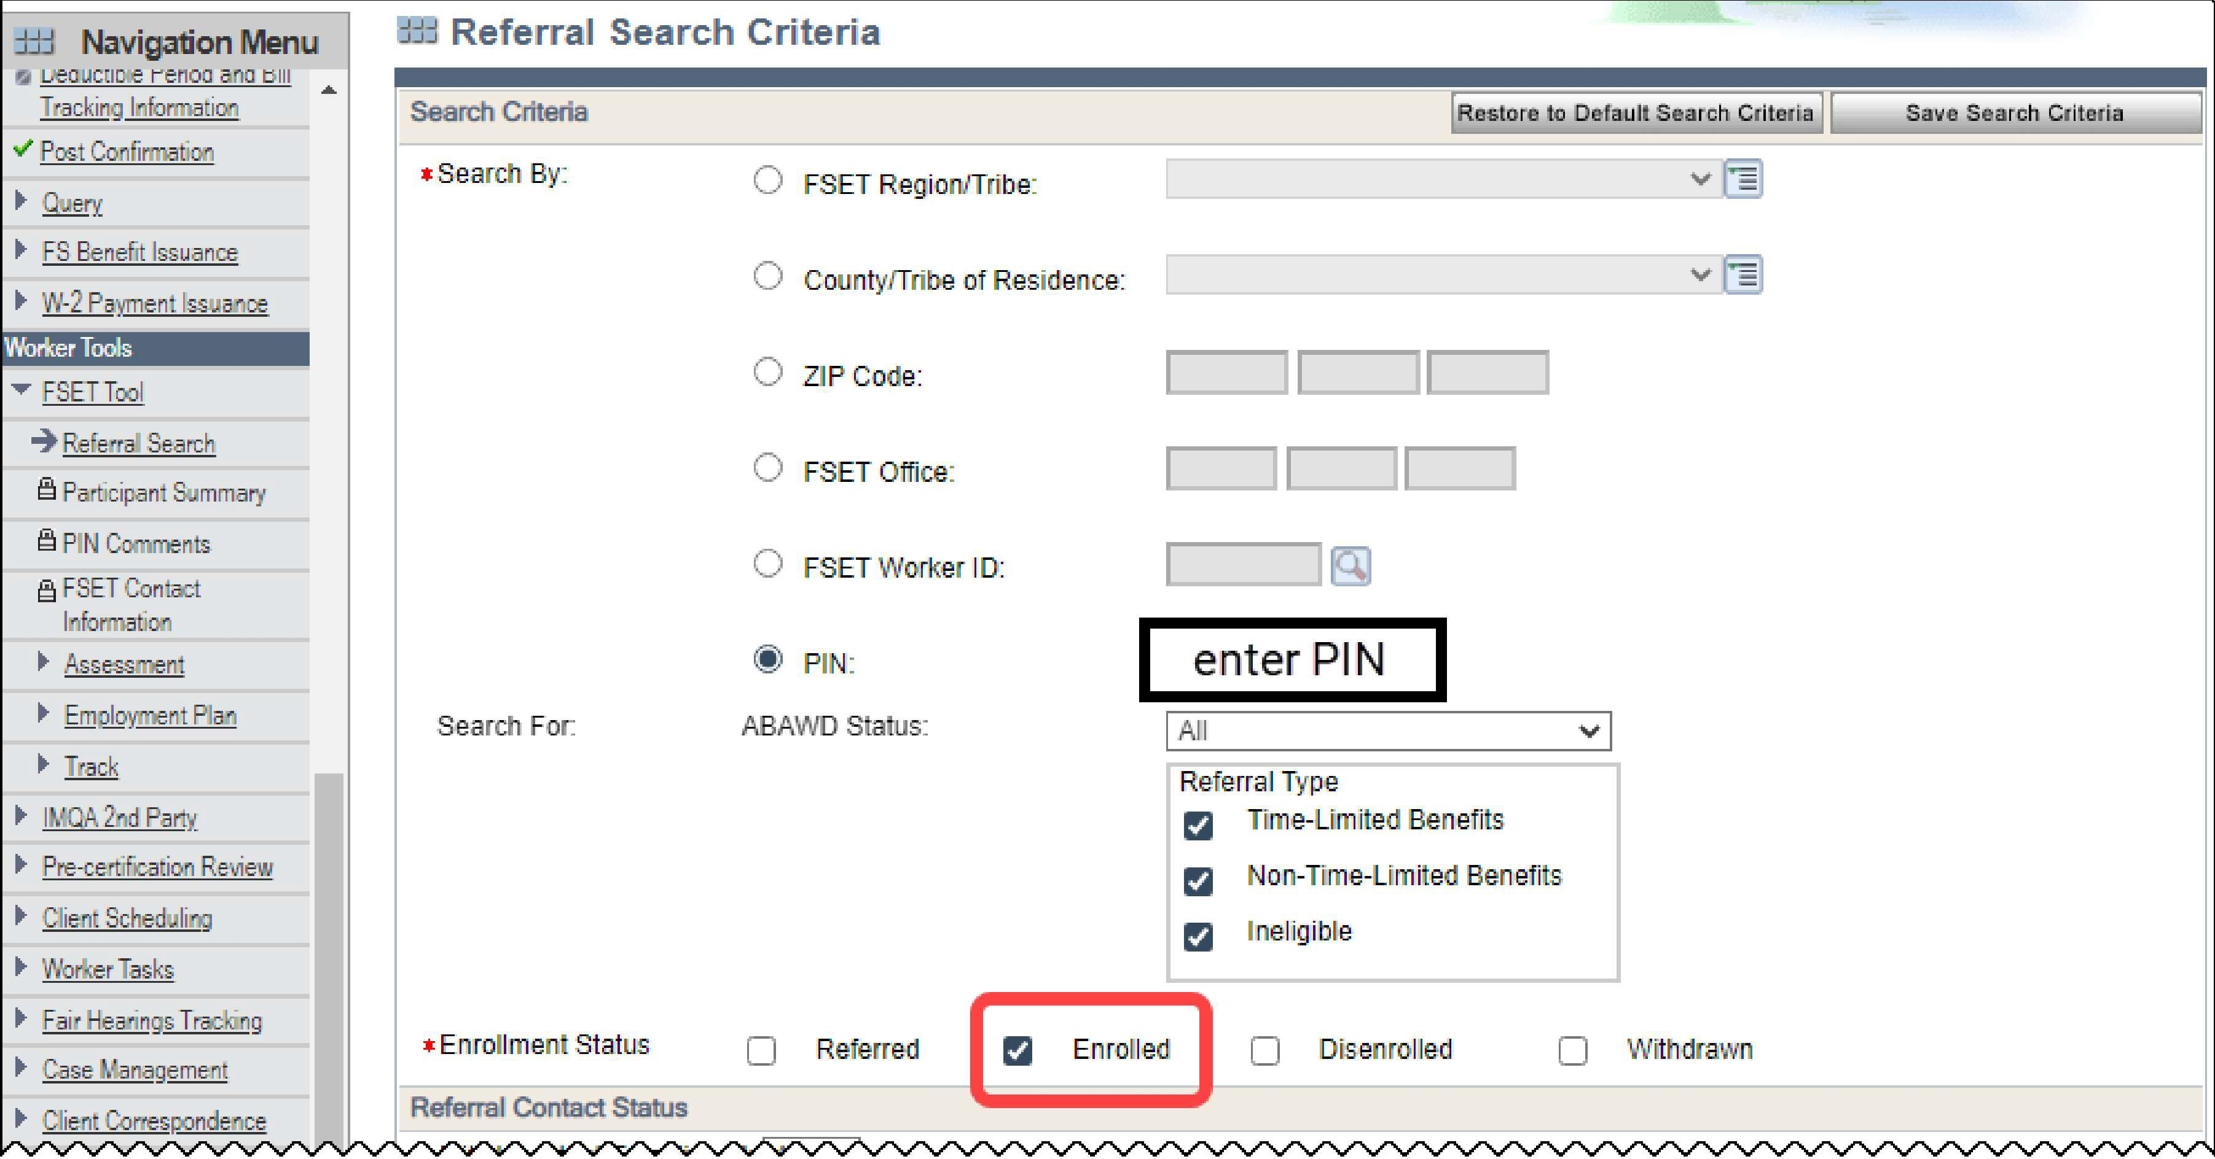
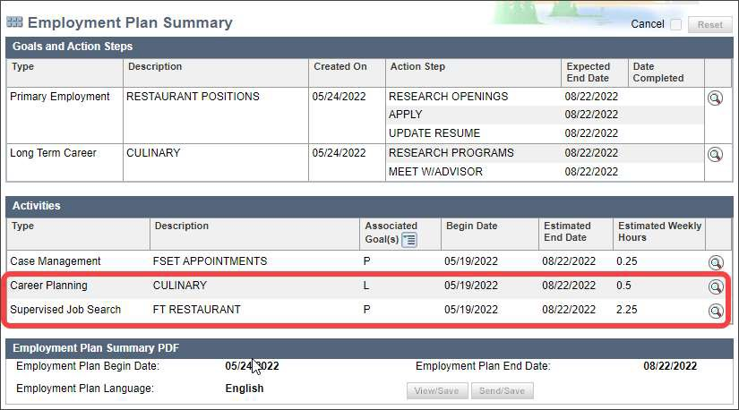
In CWW, navigate to FSET Tool > Referral Search. Select the radio button for PIN, then enter the individual's PIN. Then select an Enrollment Status of "Enrolled", scroll to the very bottom, and click "Go" in the lower-right corner.

Next, from the search results, click the magnifying glass icon along the right- hand side of the current row. On the Referral Details screen click next to unlock the FSET info.

Use the magnifying glass at the right of each row to see if there are any additional details such as assigned times in the Employment Plan Comments:

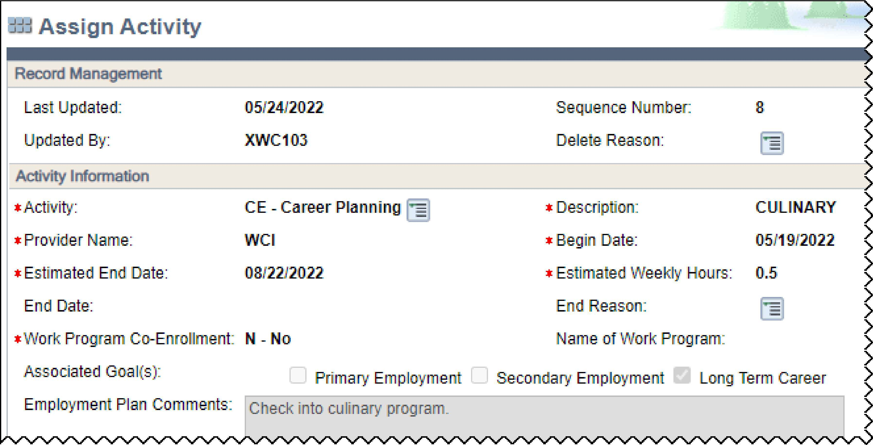
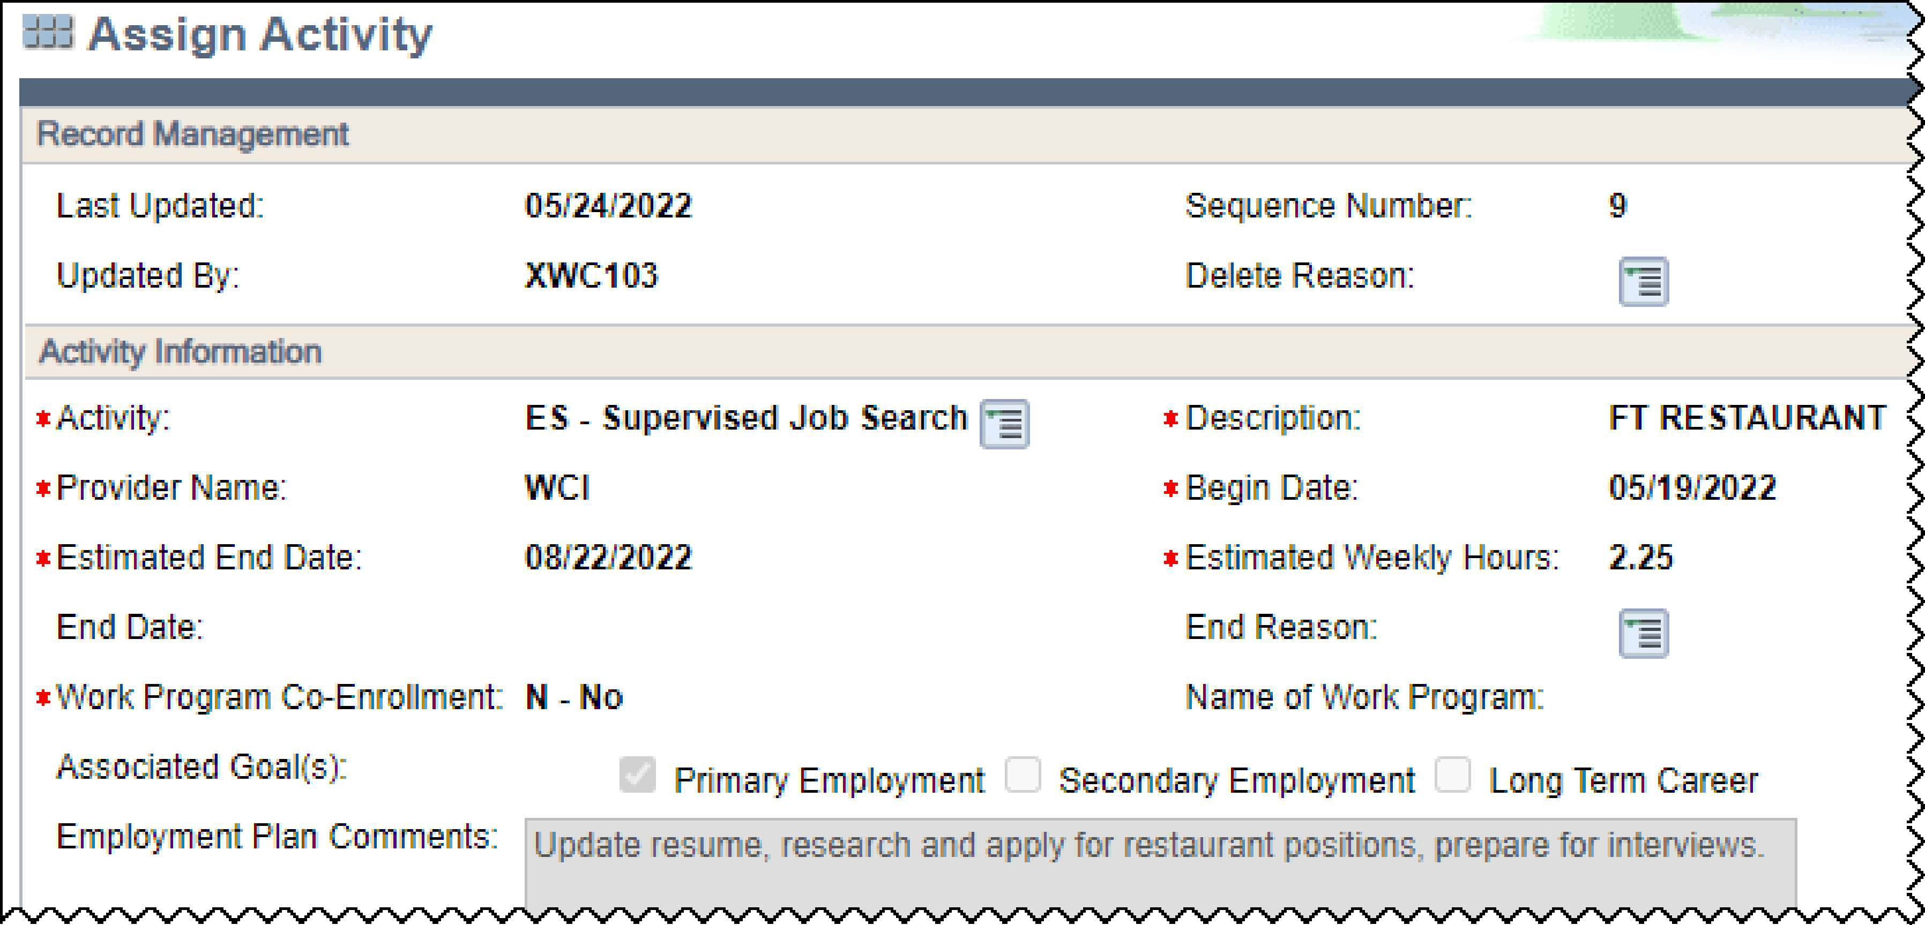
If there are no details about specific times for the activity then the parent can self-declare their schedule as long as it matches the hours listed on the EP plan.
In this example, activities included in FSET Job Search are identified as FSJS on the Child Care Activity Status page

The parent's approved activity begin and end date in CSAW should align with the EP. In this case the begin date would be 5/19/2022 with an end date of 8/22/2022. When entering this parent's approved activity schedule, use Other for the approved activity type.

Remember that there are multiple CC Approved Activity status codes that could be selected for a case with a parent participating in FSET. We'll explore that next.

To see which activities on the FSET EP correspond to which CC activity status code, begin by using the following table. These are based on Operations Memo 23-06, with one correction as noted below. As of April 2023, you may see the following codes

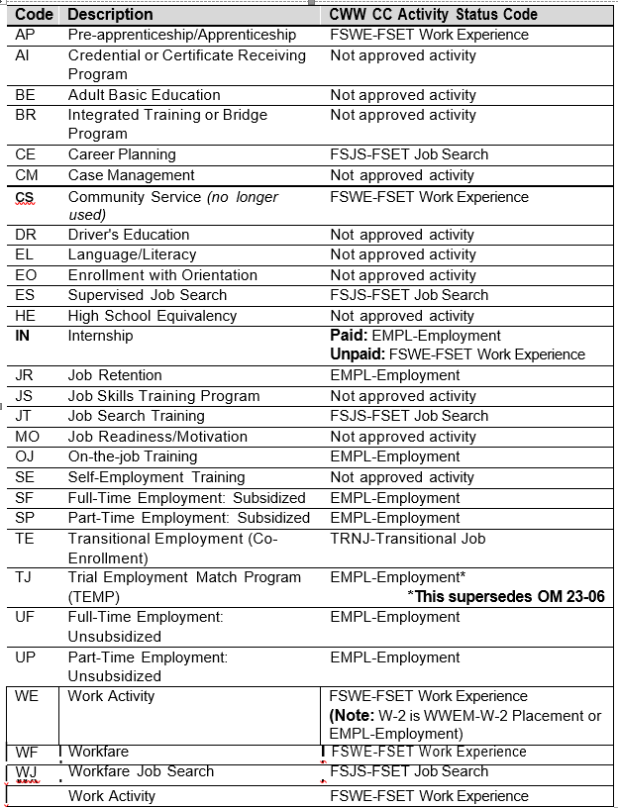

IMPORTANT! The correct CC Activity status code to use for TJ (Trial Employment Match Program) is EMPL, per section 5.1.1 of the Child Care Handbook. This supersedes the guidance in Operations Memo 23-06.

IMPORTANT! The "not approved" activities in the table above, mean "not included in the authorized hours for child care under FSET policy'. It is possible that an activity could be included if allowed per other Wisconsin Shares Policy (for example, post-secondary education).
IMPORTANT! If a parent is in multiple FSET activities, with different codes: The "Employment" (EMPL) code overrides the FSET-related codes, so if EMPL and other codes are on the case, enter EMPL. Next would be TRNJ and WWEM; use whichever one of those applies on the case if there was no activity qualifying for EMPL. If neither EMPL, TRNJ, or WWEM applied, next use FSJS or FSWE. If both FSJS and FSWE apply on a case, use the code with the larger number of weekly hours. If they are the same number of weekly hours, either FSJS or FSWE may be entered for the CC Activity Status.
Note: For the new CC Activity Status codes pertaining to self-employment, follow logic similar to the paragraph above.

Date range for parent schedule can be the entire range of the FSET EP, but only if all activities are consistent for the entire time period.

- If there is a one-time, covered activity, such as the "vocational info session", then build out that month of parent schedule as its own month, with all other activities on it plus one additional one-hour block in one of the weeks.

- If there are multiple, overlapping activities in the FSET EP, then build out a parent schedule for each date range where activities are consistent. Another way of thinking about this is, the worker "breaks up" the EP into as many pieces as needed so each piece is consistent within itself.

For authorizations, write the initial authorization to the next expected change, which may only be a month or part of a month. Then, complete a new assessment for the following month. If the hours are lower than the previous authorization, offer the parent a continuity of care authorization which can be written to the next expected change (end of EP or CC renewal, whichever comes first). If the hours are greater than or equal to the previous authorization, write the new authorization out until the next expected change, per policy.

Writing an authorization out beyond the next expected change, as well as not offering a parent an authorization based on continuity of care, are errors on a CC case.
When establishing a child's authorization, travel time can be added per policy. Remember to consider where the parent will be participating in the activity and the distance to/from the childcare provider, and then add appropriate travel time to each child's authorization.

All FSET EP information should be able to be found in CWW. However, as a last resort, there should also be a copy of the EP in ECF.

