GENESYS – Conferencing In Language Line

Follow these steps to conference in a 3rd party without the customer on the line:

- You have a caller on the line and need to conference in a 3rd party (i.e., Language Line Solutions)

- Click the CONSULT button
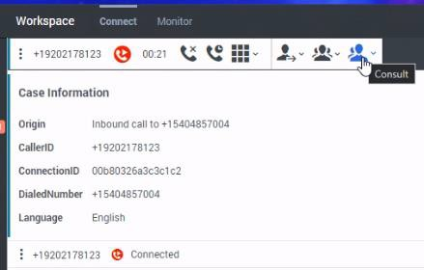

- Enter the phone number for Language Line (See chart below county by county)
  - Use the keypad on your phone versus in Genesys
  - Do not add the 1 in the phone number
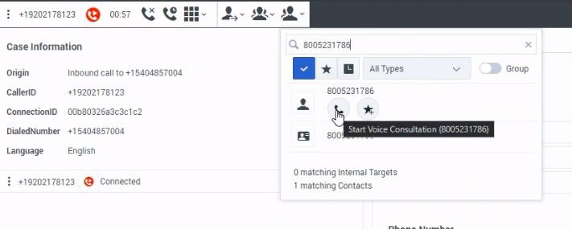

- The original caller is now on hold.
- Enter the client ID when prompted. (See chart below.)
- (DANE IM ONLY) enter the personal code when prompted. (See chart below.)
- Press 2 for Other Language (you will be prompted to say the name of the language you want an interpreter for).
- Let the operator know you have the other party on the line already.

- Once ready to loop the customer back in, click the INSTANT CONFERENCE button
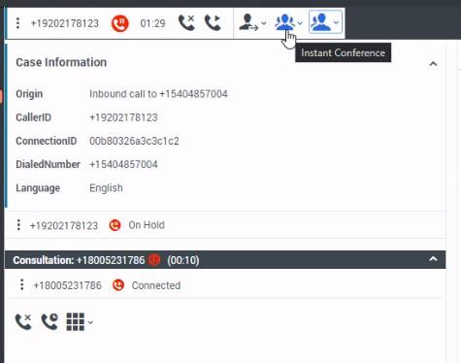

- Select the 3rd party’s phone number to add them to the call
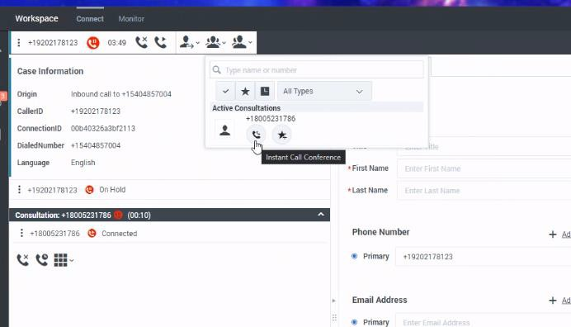

- When it is time to do the Automated Telephonic Signature, hit the instant conference button and select ATS Other for the language on the star (favorites) menu:
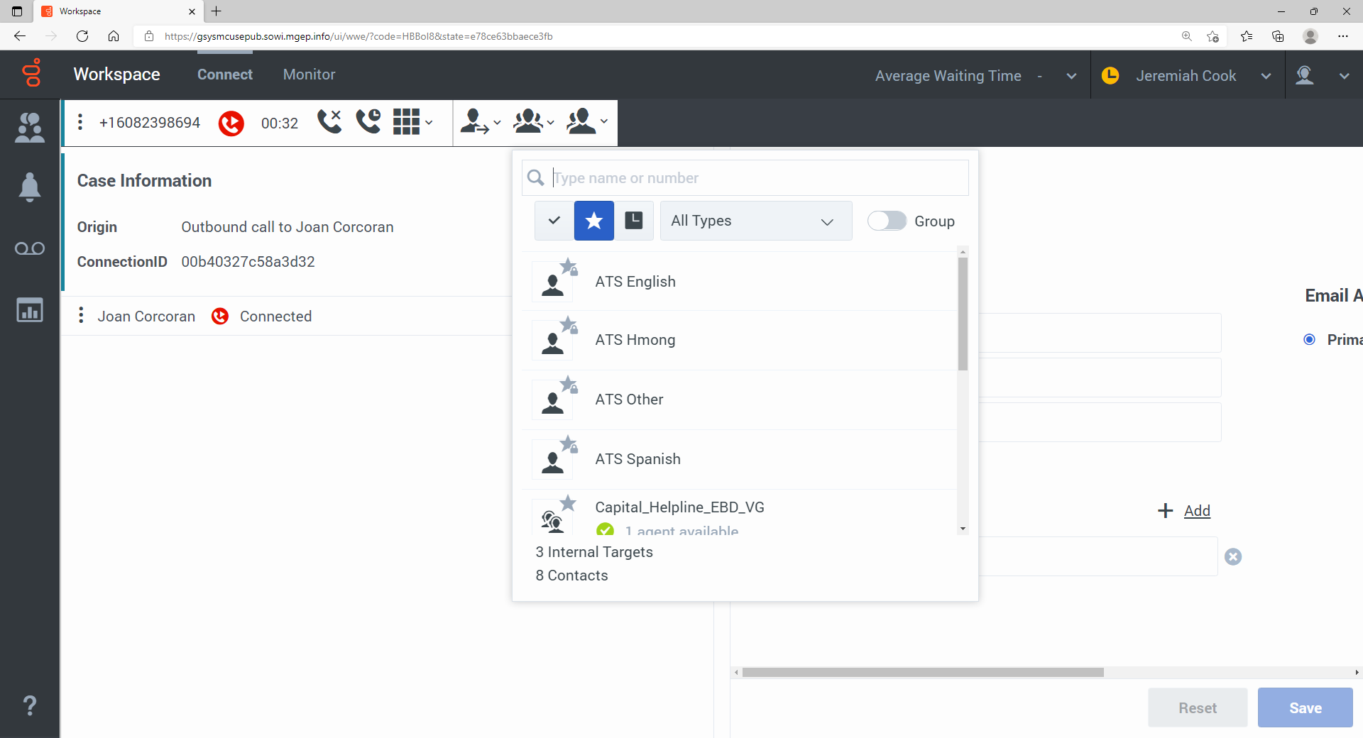

- All 4 parties will now be on the line.
- Note that unlike other ATS signatures that are recorded, there are no pre-recorded scripts for language options other than Hmong, Spanish and English. Read the text from the Generate Summary screen for all sections.

NOTE: If you do not need to speak privately to the 3rd party, you can simply click the INSTANT CONFERENCE button to loop in everyone immediately.

CHART FOR COUNTY NUMBERS/CODES FOR LANGUAGE LINE:
DANE County
Call for language interpreter by using Language Line: 1-877-261-6608. Once connected to the Language Line:
- Enter 6 digit client ID: 531092
- Press 2 for other language (you will be prompted to say the name of the language you need)
- Let the operator know if you would like to connect to multiple parties
- Dane ERS enter 27500 personal code (IM)
- Follow the remaining steps above.
Adam County
Call for language interpreter by using Language Line: 1-866-874-3972. Once connected to the Language Line:
- Enter your 6 digits client: ______________
- Press 2 for other language (you will be prompted to say the name of the language you need)
- Let the operator know if you would like to connect to multiple parties
- Follow the rest of the steps above.
Columbia County
Call for language interpreter by dialing: 1-800-225-5254 Once connected, tell them:
- Your 9 digits client ID code: _______________
- You are calling from Columbia County Health and Human Services
- Tell the line what language that you need
- Your name and Division
- 5. Let the operator know if you would like to connect to multiple parties (call a patient/client at home for example)
- Follow the rest of the steps above.
Dodge County
Call for language interpreter by using SWITS: 1-262-740-2590 SWITS (Southern WI Interpreting & Translation Services) at 262.740.2590
- Let the operator know if you would like to connect to multiple parties
- Follow the rest of the steps above.
Juneau County
Call for language interpreter by using Language Line at: 1-877-245-0386 Once connected to the Language Line:
- Enter 6 digits client ID:___________
- Press 1 for Spanish and 2 for other language (you will be prompted to say the name of the language you need)
- Let the operator know if you would like to connect to multiple parties
- Follow remaining steps above.
Richland County
Call for language interpreter by using Language Line at: 1-800-874-9426 Once connected to the Language Line:
- Enter 6 digits client ID:___________
- Press 1 for Spanish and 2 for other language (you will be prompted to say the name of the language you need)
- At some point, you will have to enter a 3 digit Access Code:_________
- Let the operator know if you would like to connect to multiple parties
- Follow the remaining steps above.
Sauk County
Call for language interpreter by using Language Line at: 1-866-874-3972 Once connected to the Language Line:
- Enter 6 digits client ID: ____________
- Press 1 for Spanish and 2 for other language (you will be prompted to say the name of the language you need)
- Brief the interpreter (Let them know you have the client on the phone, or if you need the interpreter to call them)
- Follow remaining steps above.
Sheboygan County
Call for language interpreter by using Language Line at: 1-866-874-3972 Once connected to the Language Line:
- Enter 6 digits client ID: __________
- Press 1 for Spanish and 2 for other language (you will be prompted to say the name of the language you need)
- Let the operator know if you would like to connect to multiple parties
- Follow remaining steps above.

