How to Transfer Between Queues in Genesys

- Hit the Instant Transfer Button with the caller on the line
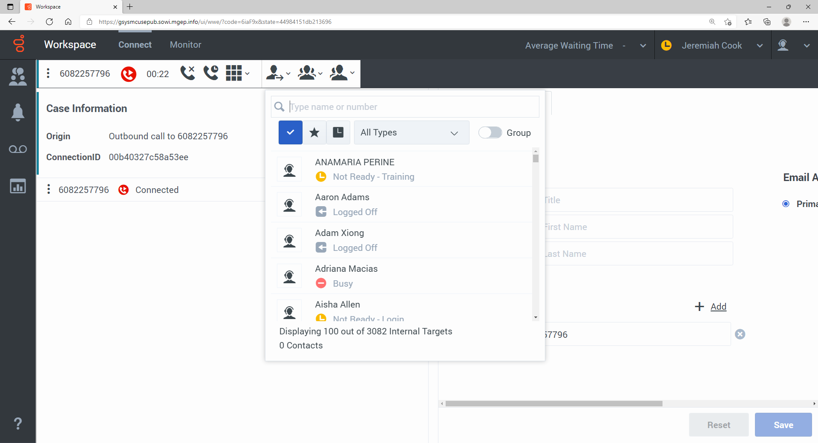

- Find the Queue you want to transfer to using the chart below
Name | Route Point(RP) | Old CCA Queue
Capital_Transfer_Gen | 51073 | General
Capital_Transfer_Esp | 51074 | Spanish
Capital_Transfer_Hmg | 51075 | Hmong
Capital_Transfer_Trans | 51076 | Translation Queue
Capital_Transfer_EBD | 51077 | EBD
Capital_Transfer_CC_Dane | 51078 | CC Dane
Capital_Transfer_CC_Sheboygan | 51079 | CC Sheboygan
Capital_Transfer_CC_Dodge | 51080 | CC Dodge
Capital_Transfer_CC_Sauk | 51081 | CC Sauk
Capital_Transfer_CC_Columbia | 51082 | CC Columbia
Capital_Transfer_CC_Richland | 51083 | CC Richland
Capital_Transfer_CC_Juneau | 51084 | CC Juneau
Capital_Transfer_CC_Adams | 51085 | CC Adams
Capital_Transfer_CC_Gen | 51086
Capital_Transfer_Helpline_EBD | 51087 | HQ EBD
Capital_Transfer_Helpline_Other | 51088 | HQ Other
Capital_Transfer_CC_Provider | 51089 | CC Provider
Capital_Transfer_CC_Other | 51090 | CC Other
Capital_Transfer_CC_Authorization_Dane | 51091 | CC Authorization Dane
Capital_Transfer_Family_Care | 51092 | Family Care
Capital_Transfer_LTC | 51093 | Long Term Care
Capital_Transfer_Training | 51094 | Training

- Type the name of the queue or RP (route point) number of the queue you want to transfer to in the search block:
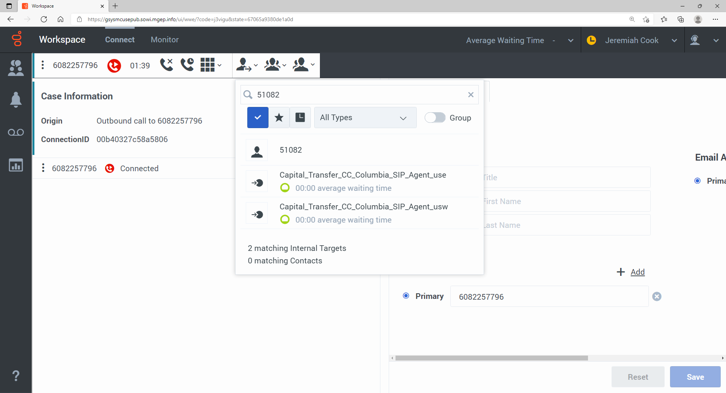

- Hover over the queue you want to transfer to and hit the instant call transfer button:
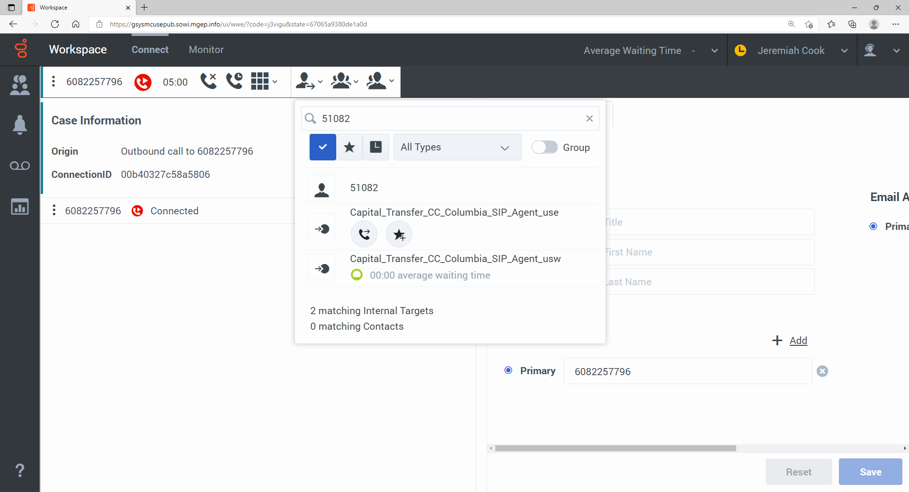
- The call will then transfer to the new queue, and you will be disconnected.
- Note: to save time, add these queues to your favorites (star). You can do so when you are not on a call in the Team Communicator. Type the name of the queue or RP number in the search block, then hit star:
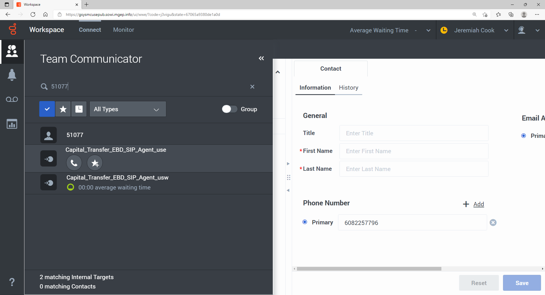
- Give the queue a reference name you will remember on the New Favorite Menu, then click ‘Add’:
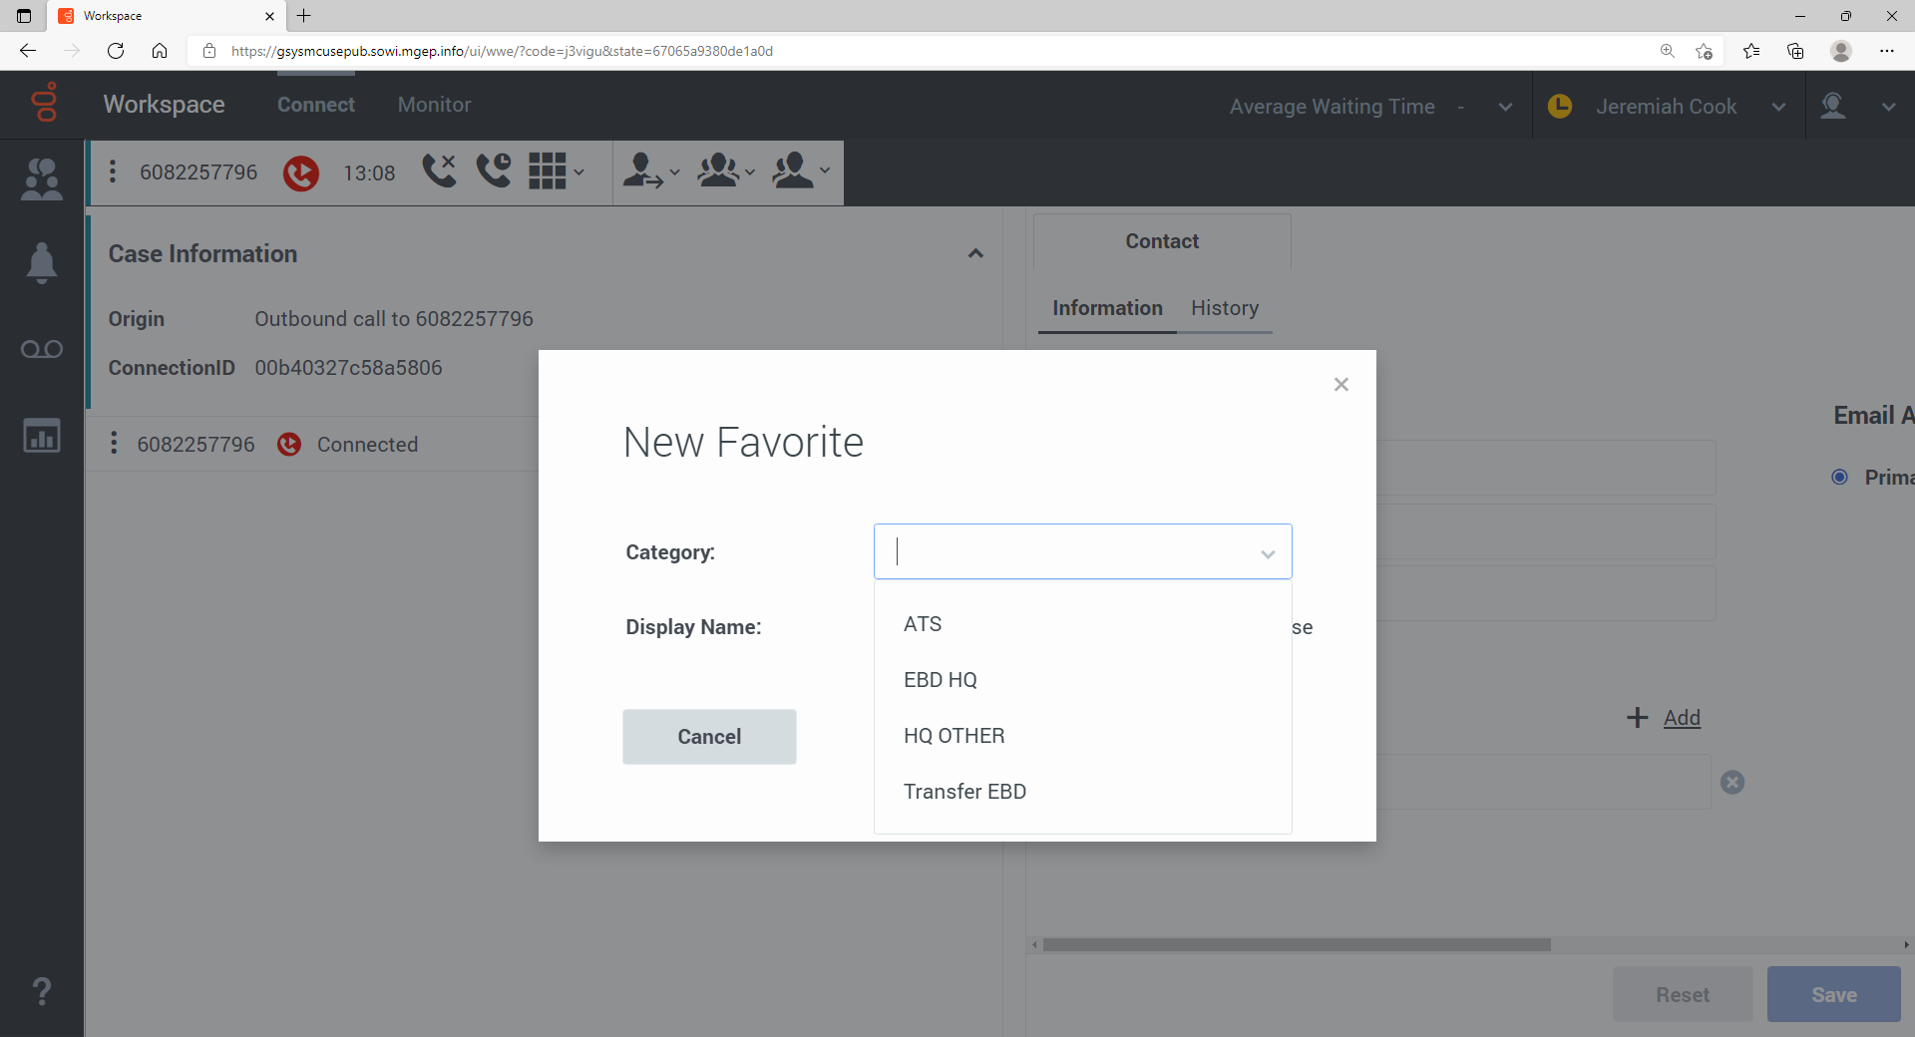

- You can reference these favorites during a transfer by hitting the star button on the transfer drop down menu:
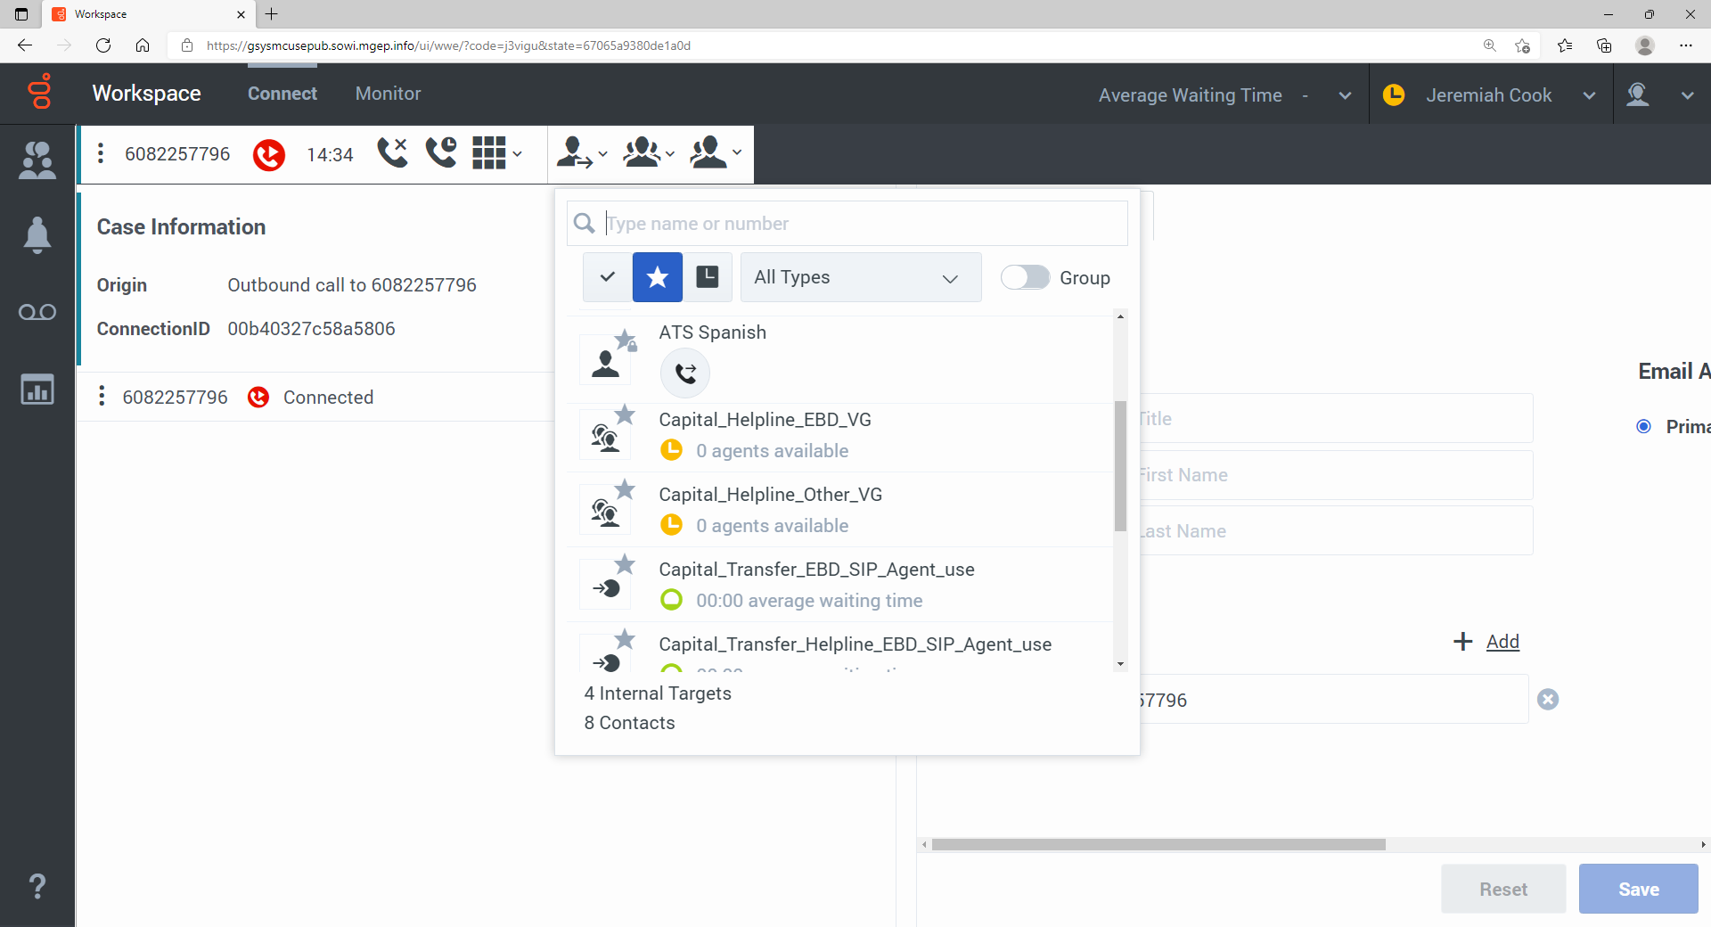

QUESTIONS: See your lead or supervisor

