HOW TO USE THE HELPQUEUE IN GENESYS

- Select the ‘Instant Consult’ button on the active call menu and type ‘help’ in the search function.
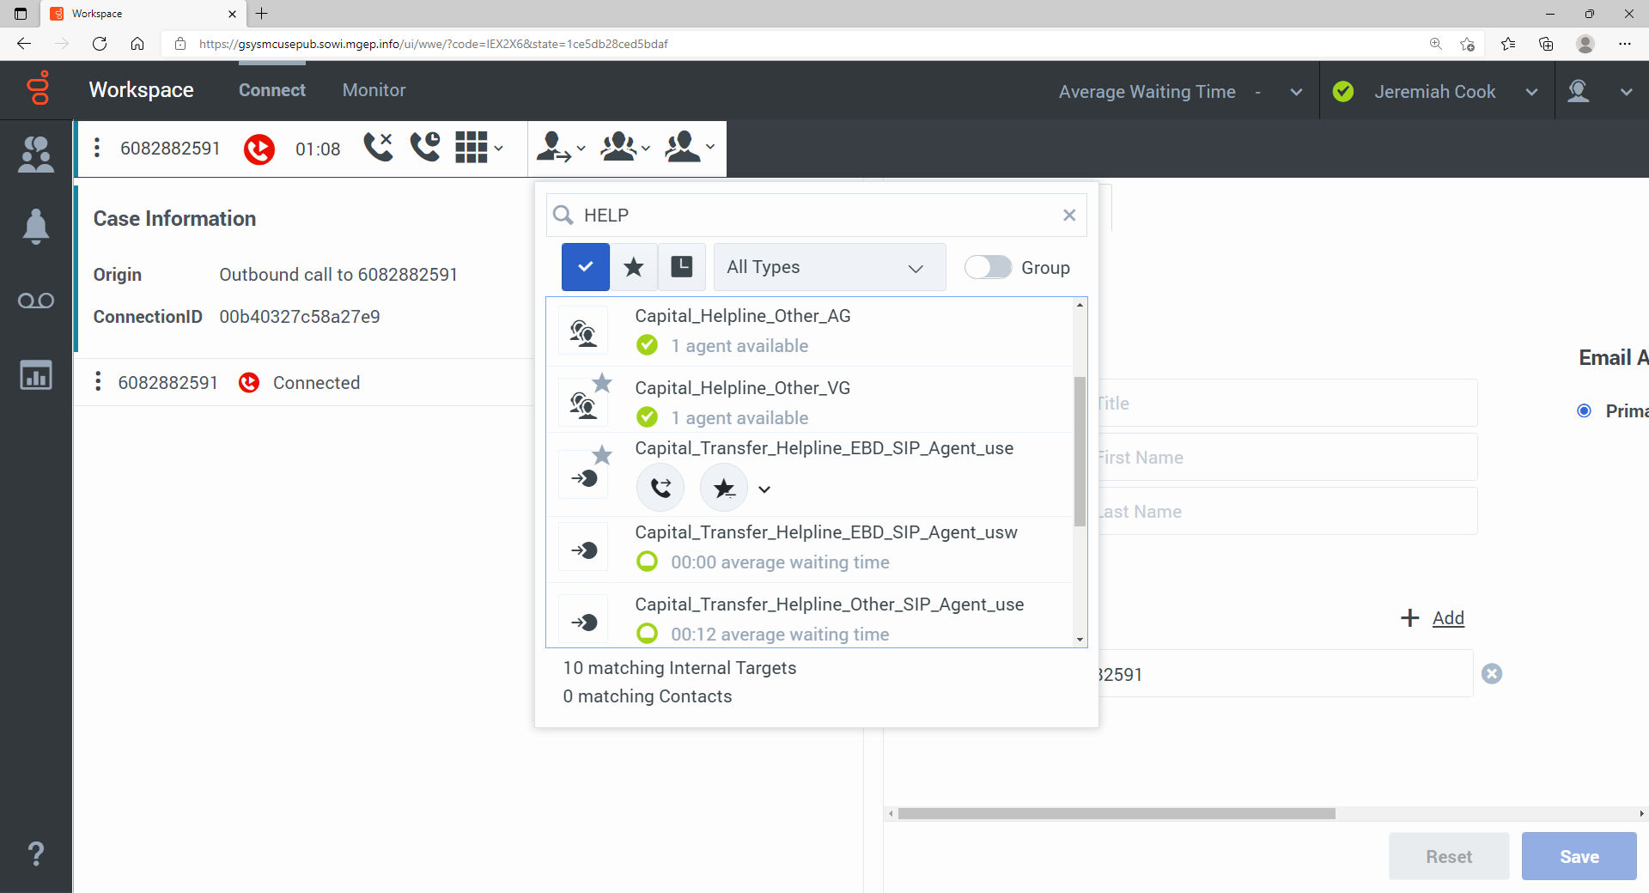
- Hover over the ‘Capital_Transfer_EBD_SIP_Agent_use’ or Capital_Transfer_OTHER_SIP_Agent_use queue and select the phone icon to place the caller on hold and contact the Helpqueue.
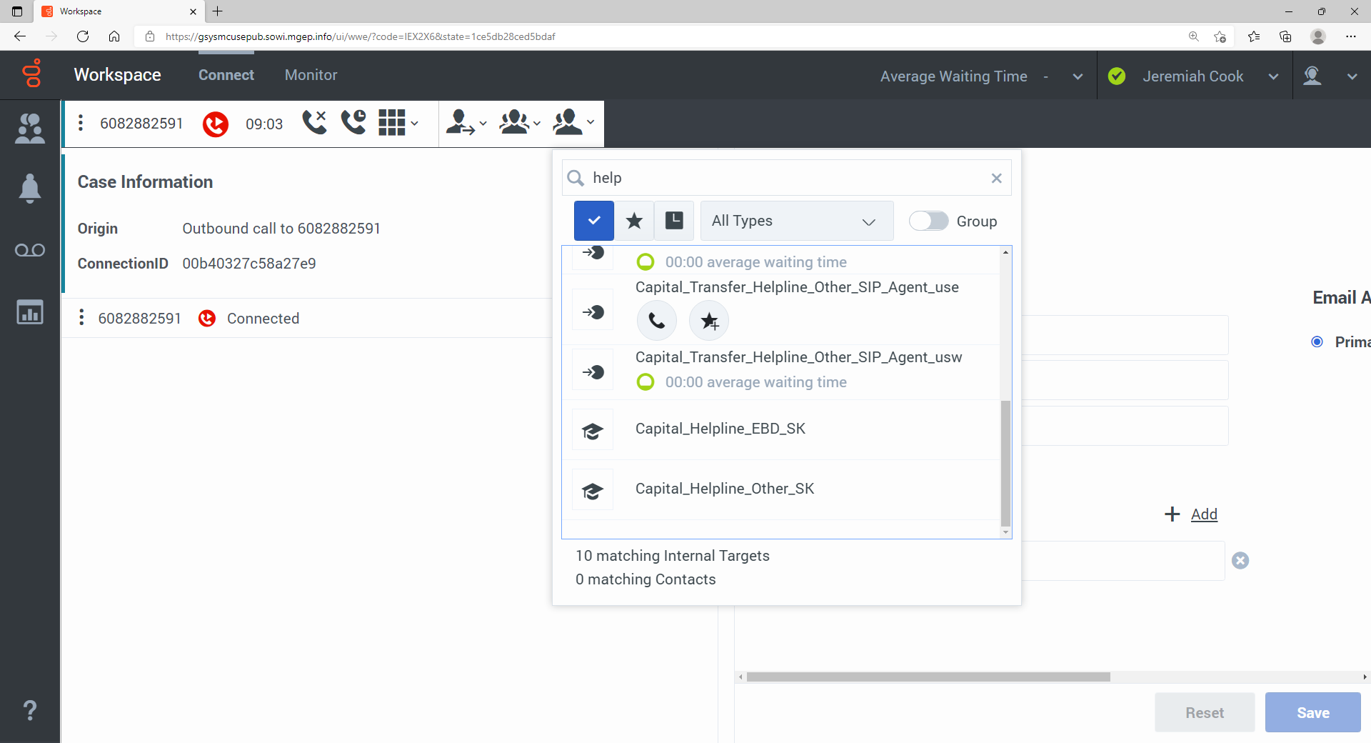
- Once you have spoken to the HQ, you may either transfer the caller to the lead you spoke with, or hang up with the lead and continue speaking with the original caller.
- To hang up with the HQ, hit the button to hang up. Then resume with the original caller.

- If instead you want to transfer the caller to the lead you spoke with, DO NOT PLACE THE LEAD ON HOLD. While the lead is on the line with you, select ‘Instant Transfer’:
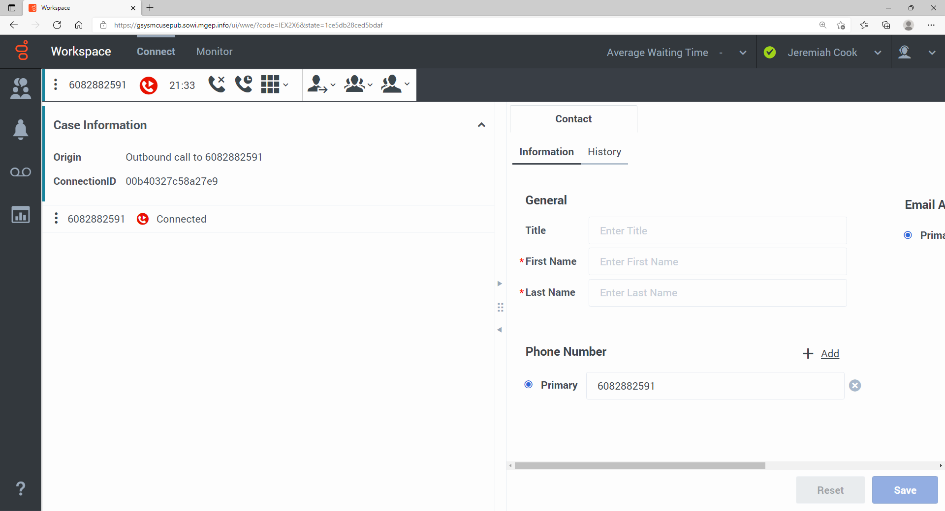
- After doing this, the lead will be connected to the original caller and you will be disconnected from both!

Any questions, see your lead or supervisor.

