Childcare authorizations for W-2 participants

Is W2 an approved activity for Childcare?
Yes, worker needs to verify W-2 is open in CWW and that the parent has a W-2 placement and the Employability Plan(EP) has been entered.

What are the valid placement codes for W-2?
- Case Management (Starts with CM): Participants are ready for a job or already have a job and need help staying employed or getting additional job skills. There is also a unique Case Management placement for individuals who are the custodial parent of an infant who is eight (8) weeks old or less.
- Community Service Jobs (CSJ): CSJ placements are for individuals who lack the basic skills and work habits needed in a regular job environment. CSJ positions offer real work training opportunities with added supervision and support.
- W-2 Transition (W-2 T): W-2 T is for individuals who have been determined not ready for unsubsidized employment and are unable to successfully participate in one of the other W-2 employment positions for reasons such as a disability or a need to care for another individual in the home who is disabled. The code is "W2T".
- At Risk Pregnancy (ARP): This placement is for unmarried women in the third trimester of pregnancy who have a medically verified at risk pregnancy.
- Trial Employment Match Program (TEMP): Participants placed into TEMP positions receive wages directly from the employer, but the wages are either partially or fully subsidized by the W-2 program. These are uncommon. Placements will have a code beginning with "T".

It is also important to be familiar with Transform Milwaukee Jobs (TMJ): These are not W-2 placements but are administered by the W-2 program. For Wisconsin Shares, this is coded on the Child Care Activity Status page as "EMPL-EMPLOYMENT" and would not need an EP for the parent schedule.
Parents participating in W-2 will also have one or more activities on their EP. Depending on the placement, activities may be optional for W-2. However, an EP must have activities in order for CC to be authorized.

How can I check the parent’s EP?
Go to CSAW and navigate to the Case Activity Summary page, click on “Show Work Program Details” button. Scroll down to locate the assigned activities.
What am I looking for on the Work Program Details (WPD) screen?
Approved W-2 activities, how often, how many hours are approved, Start Date, End Date or Planned End Date for each activity.

How can I check if a parent has a W2 placement?
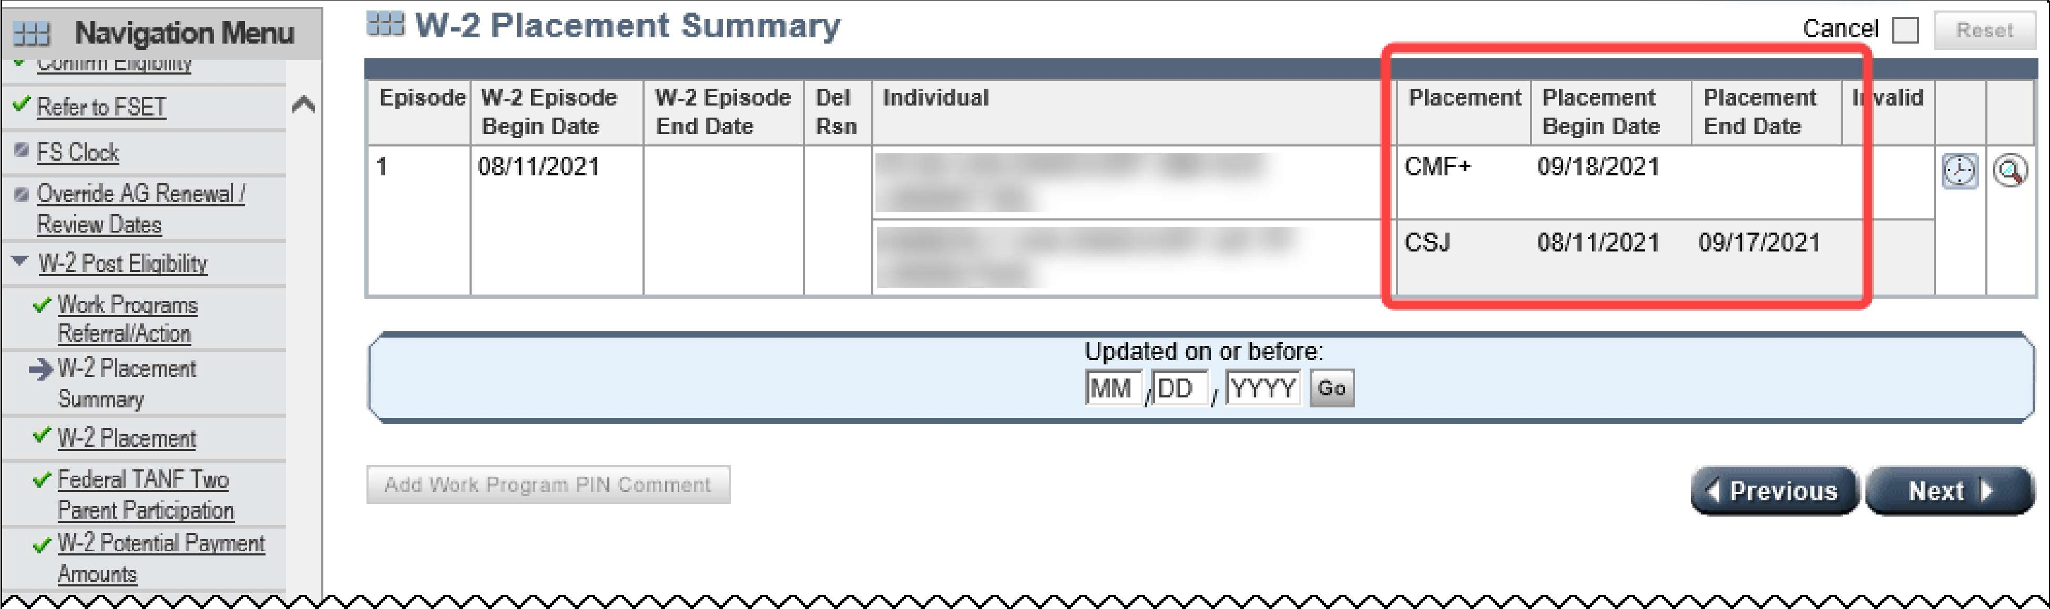
Check in CWW that W-2 is open, do a CWW search with the parent’s PIN # and select the W2 placement summary screen of the navigation menu. The summary has a column for placement and one of the above placement abbreviations should be listed with a current date. If there is nothing in the “Placement” column yet or the W-2 screens are blank then the parent must contact their FEP to finish an EP before the authorization can be entered.

If W-2 is open and a placement has been assigned, then open the case in CSAW and navigate to Case Activity Summary page click "Show Work Program Details". The Case Activity Summary will reload; scroll down and locate the Work Program Details which list the activities that have been assigned:
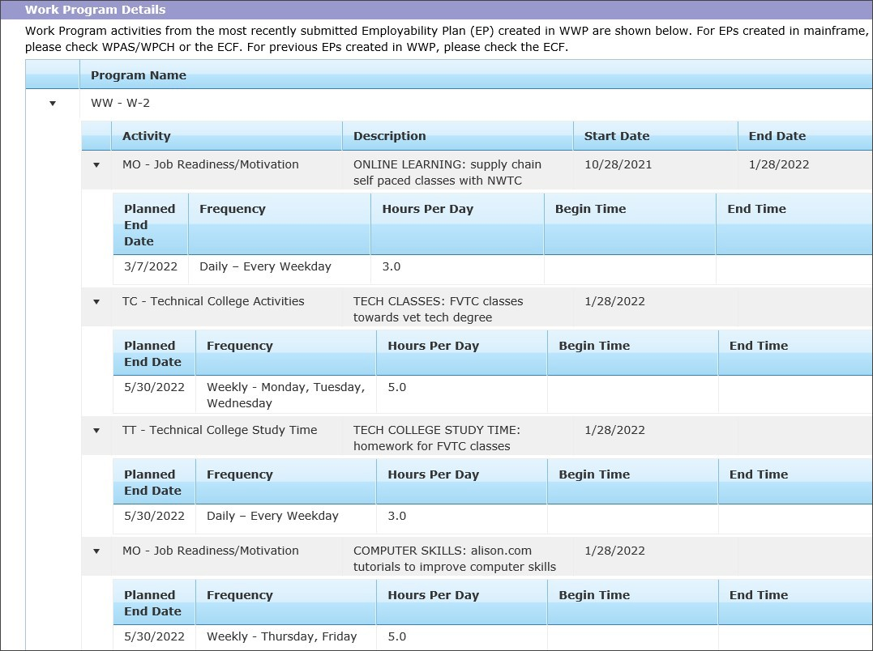

Important things to know:

- Any W-2 activity can be included in the parent approved activity schedule
- Activities that start and end on the same date can be included if the parent requests childcare for the activity.
- If there is an End Date, you can ignore the Planned End Date as an actual End Date supersedes this.
- If there are any activities with a "Monthly" frequency, you may need to establish a Four Week parent activity schedule in order to capture the schedule as accurately as possible. Otherwise, Single Week may be appropriate.
- Build separate blocks for each activity. Use the most appropriate Activity Type for each block, keeping in mind this might be "Other".
- Enter the activity on the parent approved activity schedule, only for the number of hours shown on the EP. If the time is listed on the EP, the worker should use the specific times listed. If there are no Begin or End Times, the parent can self-declare their schedule up to the number of hours approved on the EP.
- Educational activities within an individual's EP are not entered on the Education Tracking page in CSAW.
- If the WPD screen shows a range of time, for example begin time 8am and end time of 5pm but only 4hours are approved for that activity; the parent can self-declare their schedule for that activity up to the number of hours approved.

- If the information in CSAW is unclear, the next step is to check ECF. Do a Case Search and use scan code "WEP" to find the EP and review the most current one. If the EP information is still unclear, contact the FEP via e-mail. You can find the FEP’s email by clicking the link on the case summary next to the FEP name.
- Activity Status in CWW should be WWEM: Used for all W-2 placements except TMP, CMF, and CMF+ (these are EMPL-Employment).
- Employment "overrides" W-2: If the client was open for W-2 (CSJ, W-2T, TMP) and now has regular employment, work "is stronger than" the W-2 placement. The authorization may be based on employment, but must be updated and verified in CWW first. The eligibility worker would update the CC Activity status code in CWW, and re-run and re-confirm eligibility. Then, the authorization worker updates the copayment type for each child on the case to "W2 Emp End, Unsub Emp Beg" beginning the first day of the month following the change, through the annual renewal due date.
What Copayment do I use when the parent activity is W2?
When a parent is in a W-2 placement, the Copayment Type is Regular, unless the parent is in CMF or CMF+.
If in CMF or CMF+, Copayment Type should be updated to "W2 Emp End, Unsub Emp Begin" the month following when the parent begins the CMF or CMF+ placement.
For example, a parent who moved from a W-2 employment position (CSJ, W-2 T, TEMP) to regular employment (including CMF and CMF+) in April, will have the copayment type updated to "W2 Emp End, Unsub Emp Begin" as of May.

Authorizations for W-2 as an approved activity:
1. Authorization start dates are based on when the child starts attending the Childcare provider or when the EP start date is, whichever is the later.
2. Authorization end dates are based on CC case renewal/review date, EP end date or an expected change (e.g. the end of a college semester). End the authorizations on the earliest of these three dates.
3. When an EP expires and a new one is written, a new authorization assessment is required. If the result of the new assessment is for less hours the parent may choose to keep the higher level of hours during their 12mo certification period.
4. Authorizations should be entered only for the childcare need and all other authorization requirements such as providers hours of operations, school hours for school-aged children, two parent household should be followed.
5. Standard Travel time rules apply
Steps When Requesting an Authorization for W-2 activities:
- The client contacts the local CC agency to request a childcare authorization for their W2 EP.
- Authorization worker verifies CC eligibility is open and ongoing, and a current W-2 placement exists in CWW on the W2 placement summary screen of the navigation menu.
- Worker checks the W-2 EP activities on the Case Activity Summary page in CSAW by clicking on the “Show Work Program Details button. If the details cannot be viewed in CSAW, check ECF scan code WEP to find EP’s.
- If there is nothing in the “Placement” column yet or the W-2 screens are blank then the parent must contact their FEP to finish an EP before Child Care can be authorized.
- Using the EP, the worker asks the parent about any activities on the W-2 EP that are unclear or don't have assigned dates and/or times.
- The authorization is completed per the authorization assessment and the worker enters case comments.

