BABY ADD (Process Help 3.1)
When a newborn's birth is reported, navigate to the Pregnancy page for the mother and enter the newborn’s birth date in the Pregnancy End Date field to end the pregnancy. This ends the pregnancy and begins the pregnancy extension correctly. Do not end date the Pregnancy page at this time, doing so at this time causes the pregnancy extension to fail. It is recommended to end date and delete this page at the next renewal.
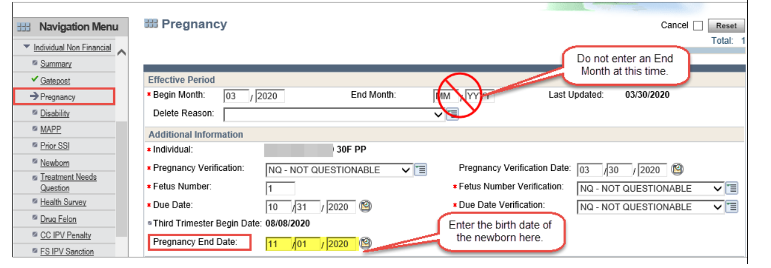
Click Next to continue through the mini driver flow.
In some circumstances, the Treatment Needs Question (TNQ) page schedules in the driver flow after the Pregnancy End Date is entered on the Pregnancy page. Update the Begin Month to the month the newborn was born. The ?-Response Not Yet Provided auto-populates for the TNQ response. The response to this question is only required for a childless adult and will not cause eligibility for the pregnancy extension to pend or fail.
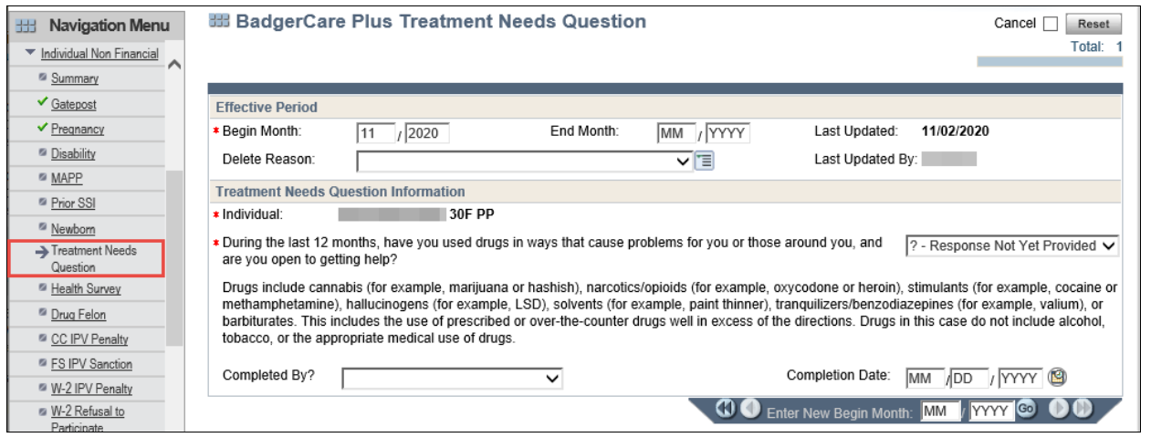
Continue the driver through to the Initiate Eligibility page.
Initiate Eligibility, and confirm the pregnancy extension on the Confirm Eligibility page in CWW.
Click the "Add Person" work flow option from the Case Summary page to initiate the driver flow. Enter the birth month of the newborn into the Enter Begin Month for New Data field, at the bottom of the page before clicking Next.
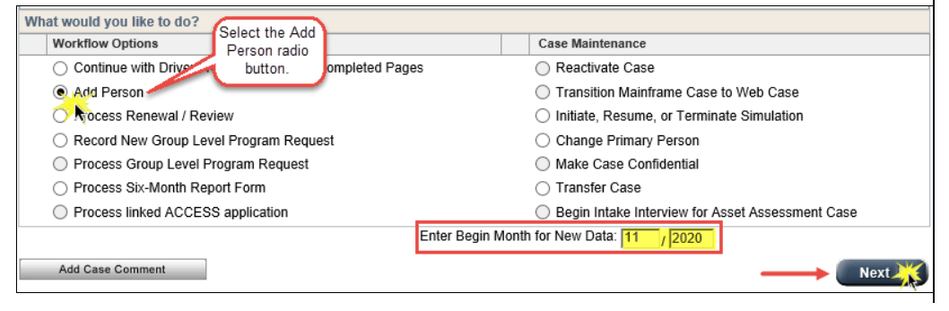
The Household Members page displays.
Enter the known information for the newborn on the Household Members page.
If the SSN is provided, enter the SSN in the SSN field with a C (Completed Requirements) verification code. If no SSN is provided leave the SSN field blank. An SSN is entered once it is provided.
Click Next.
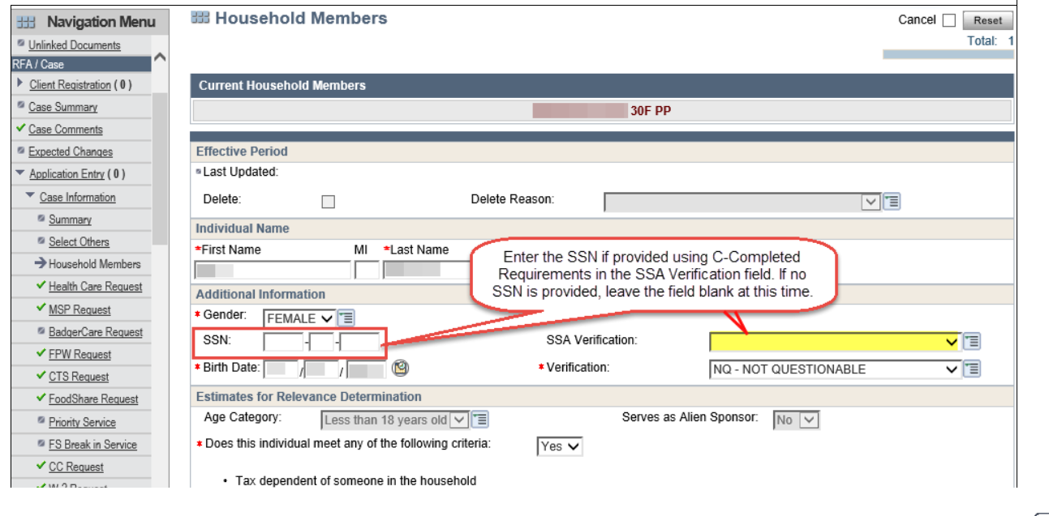
The Program Request pages display.
Enter the newborn's birth month into the Begin Month field and their birth date into the Program Filing Date field. Update the Individual Request for the newborn on all of the Program Request pages. The “AE779 PERSON ADD-Update the ‘Begin Month’ and ‘Program Filing Date’ in order to run eligibility successfully” banner displays on each Program Request page.
Fiscal agent staff not to update any dates. IM workers must return to these pages and update the dates so that eligibility runs successfully.
Click Next.
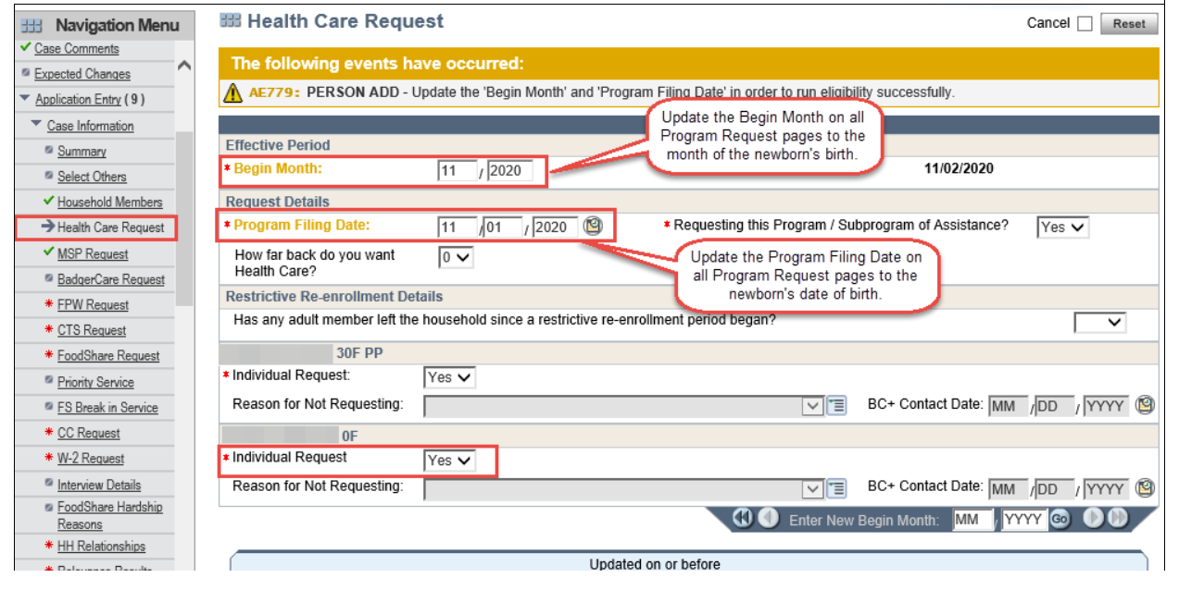
The Household Relationships page displays.
Enter the correct relationships of each household member to one another and update the verification codes when appropriate.
Fiscal agent staff are trained to complete this step with the information available to them. IM workers must review the relationships for accuracy.
The Relevance Results page displays, review the newborn’ information for accuracy and click Next and clearance and the relevance runs on the newborn.
The Individual Clearance Results page displays. The newborn is determined relevant.
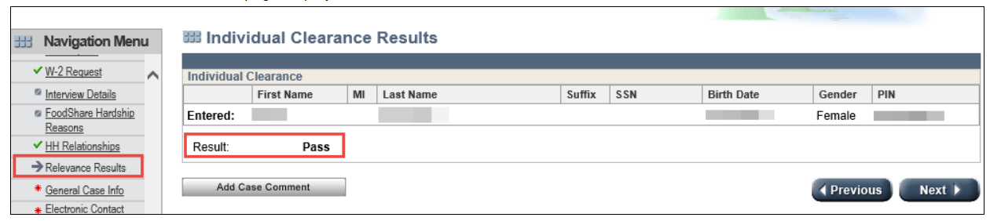
Once the newborn is through clearance and relevance, CARES assigns an MCI and PIN number to the newborn. The MCI ID and PIN numbers are viewable on the Individual Summary page or the Case Member History page. This MCI ID number is the newborn’s Member ID for claim billing purpose in Interchange. This member ID number is used for any manual certification within interchange.
Permanent Demographics page displays. Complete this page with the information known about the newborn. Pay special attention to the following fields.
US Citizenship MA Verification
This field on the Permanent Demographics page is important for health care and must be properly coded. CEN's are exempt from the citizenship verification requirement (BCHB 4.2.2) the "NB-Continuously Eligible Newborn" code must be entered in the US Citizenship MA Verification field for CENs. Not all newborns are CEN's. See BC+HB 8.2 for CEN policy. If a birth query is available for a newborn that is not considered a CEN, enter the "BQ-Birth Query" verification code and enter the State File Number.
SSN Application Date:
Many hospitals provide the mother with an SSN application at the time of delivery. A copy of this form can be used to verify the SSN Application Date. See FSHB 3.13.1.2. Complete the rest of the page and click Next.
SSN Override Verification:
If an SSN or the SSN application date isn’t provided, enter a “?-Not Yet Provided” in the SSN Override Verification field. Eligibility doesn’t pend MAGB for the SSN Override Verification until renewal.
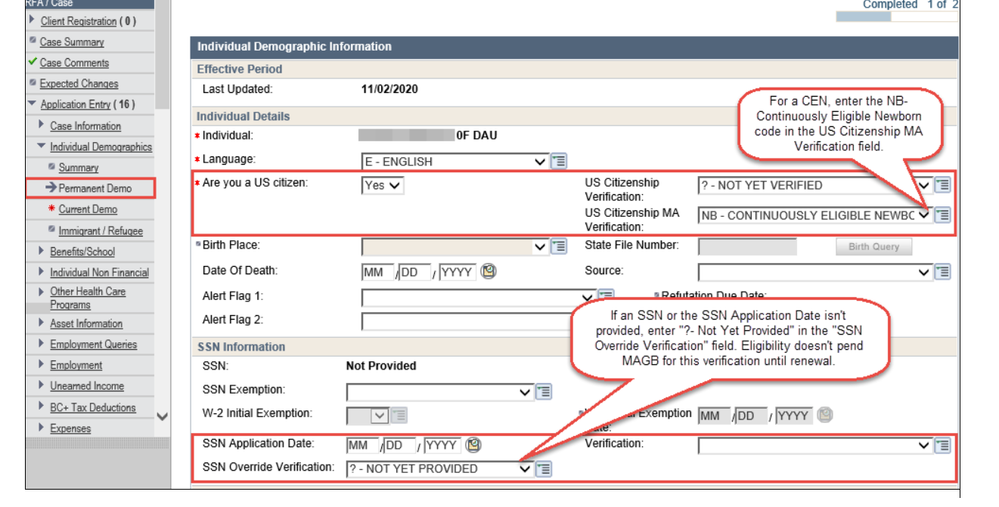
CARES automatically populates the US Citizenship Verification and US Citizenship MA Verification fields with NX − CONTINUOUSLY ELIGIBLE NEWBORN when an individual is confirmed eligible for BadgerCare Plus in CARES as a continuously eligible newborn with an assistance group type of MAGB.
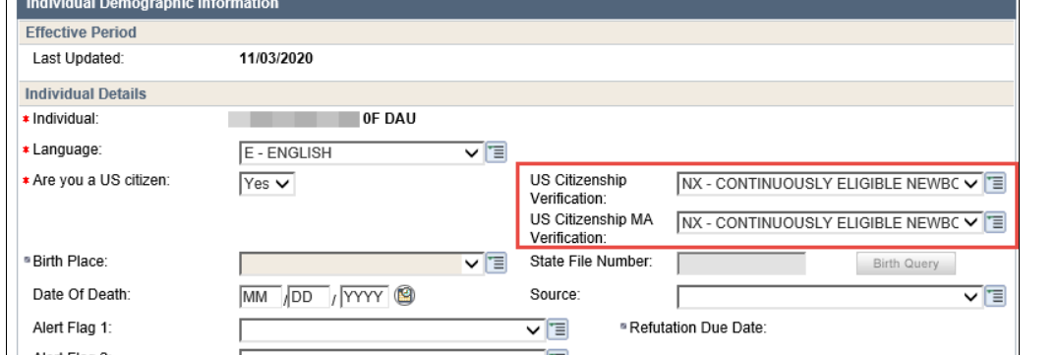
Current Demographics page displays:
Complete this page with the newborn's information. Pay special attention to the following fields:
Effective Period:
Enter the newborn’s birth month into the Begin Month field.
Identity Verification:
Enter a verification code in the Identity Verification field for non-Health Care programs based on program requirements. Entering a “?-Not Yet Verified code” in this field pends non-Health Care programs when identity verification is required.
Identity MA Verification:
The Identity MA Verification field is auto-populated with the verification code entered for the US Citizenship MA verification field on the Permanent Demographics page.
SSN Cooperation:
The SSN Cooperation field is required to be completed for all programs. This field must be updated appropriately according to each program policy.
Living Arrangement Information:
Enter the newborn’s birth month in the Effective Period Begin Month field. Enter the Living arrangement code “01-Independent (HOME/APT/TRLR”. 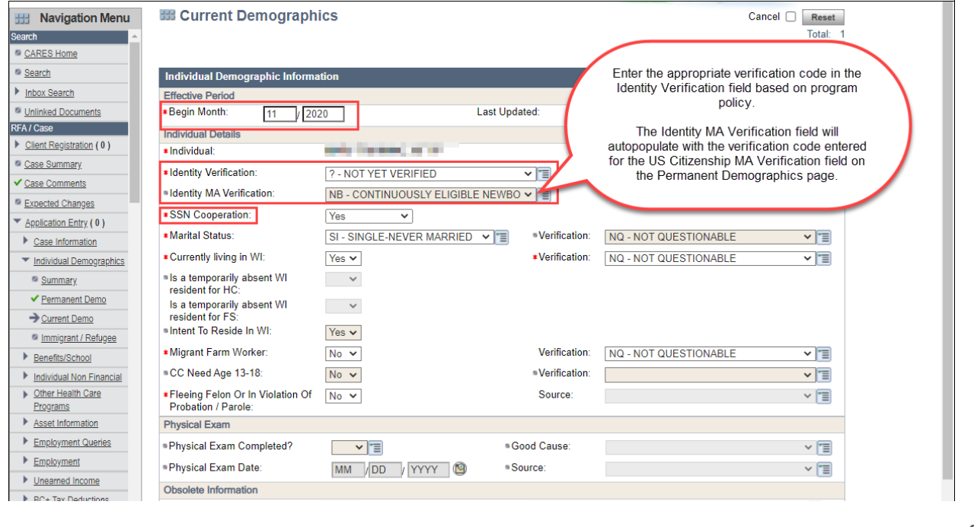 Click Next.
The Benefits Received page displays. Answer the questions appropriately and click Next.
The Individual Non-Financial Gatepost page displays.
Answer Yes to the question "Is anyone in your household under age 13 months?" and click Next. This schedules the Newborn page.
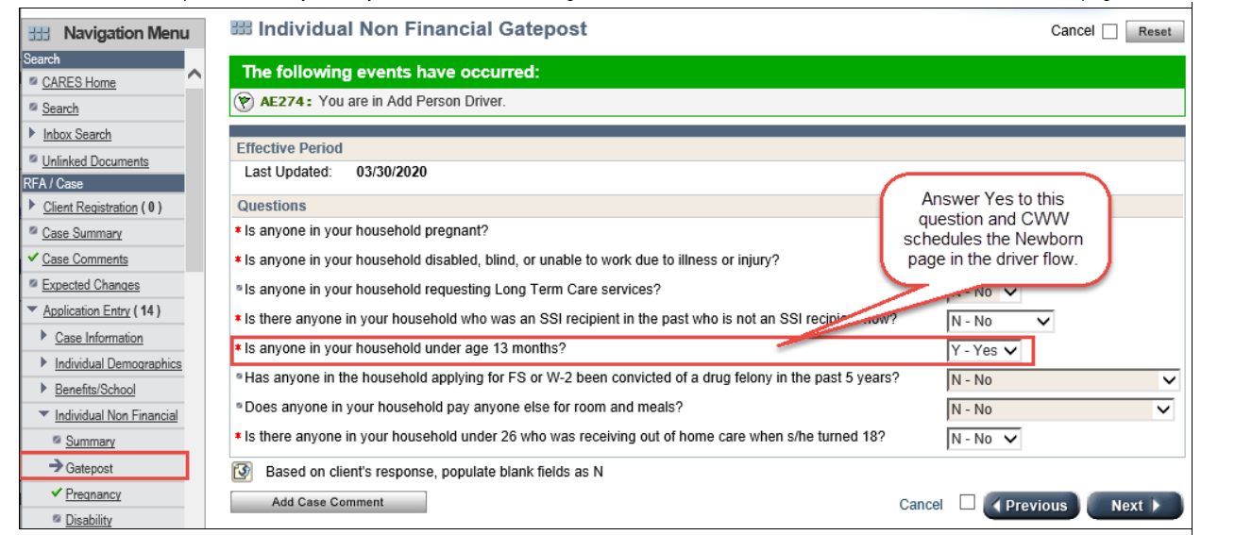
The Newborn page displays.
When entering Newborn details, it is important to answer the question "Was the child’s mother eligible for any non-CARES MA at the time of the child’s birth?" correctly.
Answer Yes if the mother received non-CARES MA such as:
- Emergency Services Medicaid or
- Katie Becket or
- SSI Medicaid or
- Foster Care Medicaid or
- Adoption Assistance Medicaid or
- Wisconsin Well Woman Medicaid.
- BadgerCare Plus Prenatal Program (as a non-qualifying immigrant)
Answer No if the mother is open for BadgerCare Plus or Medicaid in CARES when the baby is born.
Click Next.
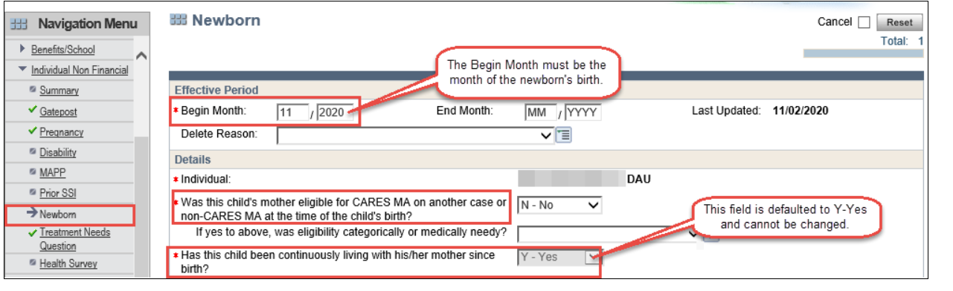
he Absent Parent page displays when one or both parents of the newborn are not living in the household. CARES determines whether or not there is an absent parent from information entered on the household relationships page. For information about how to complete the Absent Parent page, SEE PH 65.0 ABSENT PARENT. Update the Absent Parent page with any information provided regarding the absent parent’s information.
Workers must take the following steps to update the Absent Parent page when adding a newborn to the case.
- Select the Pencil Icon
- Click the “Delete” box
- Enter “LB-Live Birth” for the Delete Reason
- Select Update.
- Select the Newborn from the “Individual” drop down
- Select the Legal Parentage Status
- Select Add.
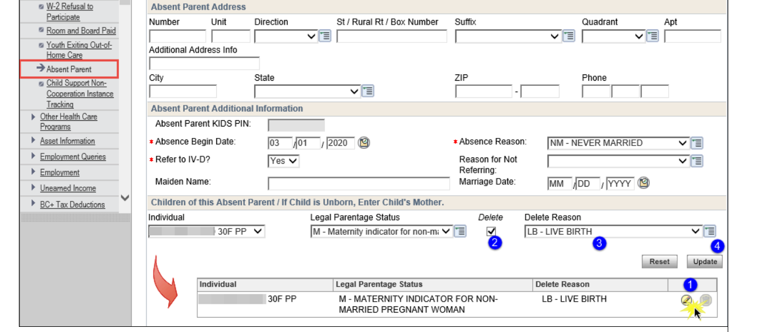
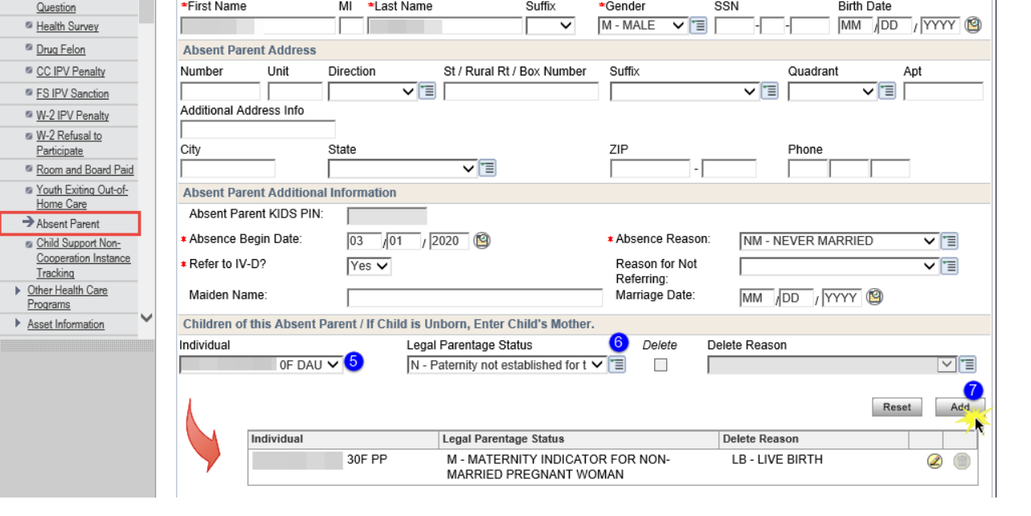
- The Employment, Unearned Income Expense BC+ Tax Deduction, and Medical Gatepost pages are scheduled in the person add driver flow. Update these pages with any information provided. Click Next.
- The Tax Filing Details page displays. Update this page based on the information the member provides about their tax filing circumstances.
- The Generate Summary page displays. Update the “What would you like to do” field to NA-Do Not Generate and click Next. Refer to PH 1.6.1.8 about when a summary must be generated.
- Initiate Eligibility page displays.
- Run eligibility with dates beginning with the month of the newborn's birth. After the eligibility results are reviewed and determined correct (MAGB for a CEN eligible newborn) confirm on the Confirm Eligibility page in CWW.
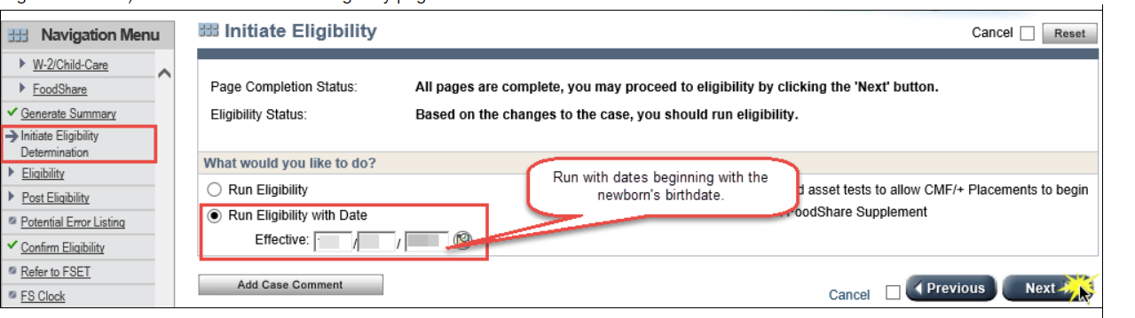
- Return to the Initiate Eligibility page and run eligibility for recurring months of eligibility. When eligibility is correct (MAGB for a CEN eligible newborn), confirm on the Confirm Eligibility page in CWW.
- Supplement FoodShare and Caretaker Supplement benefits as appropriate

